Genetic Code

Genetic code, the sequence of nucleotides in deoxyribonucleic acid (DNA) and ribonucleic acid (RNA) that determines the amino acid sequence of proteins. Though the linear sequence of nucleotides in DNA contains the information for protein sequences, proteins are not made directly from DNA. Instead, a messenger RNA (mRNA) molecule is synthesized from the DNA and directs the formation of the protein. RNA is composed of four nucleotides: adenine (A), guanine (G), cytosine (C), and uracil (U). Three adjacent nucleotides constitute a unit known as the codon, which codes for an amino acid. For example, the sequence AUG is a codon that specifies the amino acid methionine. There are 64 possible codons, three of which do not code for amino acids but indicate the end of a protein. The remaining 61 codons specify the 20 amino acids that make up proteins. The AUG codon, in addition to coding for methionine, is found at the beginning of every mRNA and indicates the start of a protein. Because most of the 20 amino acids are coded for by more than one codon, the code is called degenerate.

The genetic code, once thought to be identical in all forms of life, has been found to diverge slightly in certain organisms and in the mitochondria of some eukaryotes. Nevertheless, these differences are rare, and the genetic code is identical in almost all species, with the same codons specifying the same amino acids. The deciphering of the genetic code was accomplished by the American biochemists Marshall W. Nirenberg, Robert W. Holley, and Har Gobind Khorana in the early 1960s.

Nucleotide triplets (codons) specifying different amino acids are shown in the table.

| **The genetic code: Nucleotide triplets (codons) specifying different amino acids in protein chains\*** | | |
| --- | --- | --- |
| *The columns may be read: the DNA triplet is transcribed into an RNA triplet, which then directs the production of an amino acid. | | |
| **DNA triplet** | **RNA triplet** | **amino acid** |
| **AAA** | UUU | phenylalanine |
| **AAG** | UUC |  |
| **AAT** | UUA | leucine |
| **AAC** | UUG |  |
| **GAA** | CUU |  |
| **GAG** | CUC |  |
| **GAT** | CUA |  |
| **GAC** | CUG |  |
| **AGA** | UCU | serine |
| **AGG** | UCC |  |
| **AGT** | UCA |  |
| **AGC** | UCG |  |
| **TCA** | AGU |  |
| **TCG** | AGC |  |
| **GGA** | CCU | proline |
| **GGG** | CCC |  |
| **GGT** | CCA |  |
| **GGC** | CCG |  |
| **TAA** | AUU | isoleucine (Ileu) |
| **TAG** | AUC |  |
| **TAT** | AUA |  |
| **TAC** | AUG | methionine |
| **TGA** | ACU | threonine |
| **TGG** | ACC |  |
| **TGT** | ACA |  |
| **TGC** | ACG |  |
| **CAA** | GUU | valine |
| **CAG** | GUC |  |
| **CAT** | GUA |  |
| **CAC** | GUG |  |
| **CGA** | GCU | Alanine |
| **CGG** | GCC |  |

Expression of the genetic code: transcription and translation

DNA represents a type of information that is vital to the shape and form of an organism. It contains instructions in a coded sequence of nucleotides, and this sequence interacts with the environment to produce form—the living organism with all of its complex structures and functions. The form of an organism is largely determined by protein. A large proportion of what we see when we observe the various parts of an organism is protein; for example, hair, muscle, and skin are made up largely of protein. Other chemical compounds that make up the human body, such as carbohydrates, fats, and more-complex chemicals, are either synthesized by catalytic proteins (enzymes) or are deposited at specific times and in specific tissues under the influence of proteins. For example, the black-brown skin pigment melanin is synthesized by enzymes and deposited in special skin cells called melanocytes. Genes exert their effect mainly by determining the structure and function of the many thousands of different proteins, which in turn determine the characteristics of an organism. Generally, it is true to say that each protein is coded for by one gene, bearing in mind that the production of some proteins requires the cooperation of several genes.

Proteins are polymeric molecules; that is, they are made up of chains of monomeric elements, as is DNA. In proteins, the monomers are amino acids. Organisms generally contain 20 different types of amino acids, and the distinguishing factors that make one protein different from another are its length and specific amino acid sequence, which are determined by the number and sequence of nucleotide pairs in DNA. In other words, there is a colinearity (i.e., parallel structure) between the polymer that is DNA and the polymer that is protein.

Hence, genetic information flows from DNA into protein. However, this is not a single-step process. First, the nucleotide sequence of DNA is copied into the nucleotide sequence of single-stranded RNA in a process called transcription. Transcription of any one gene takes place at the chromosomal location of that gene. Whereas the unit of replication is a whole chromosome, the transcriptional unit is a relatively short segment of the chromosome, the gene. The active transcription of a gene depends on the need for the activity of that particular gene in a specific tissue or at a given time.

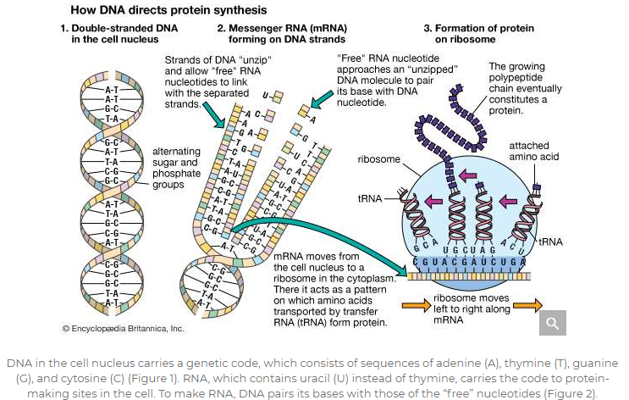

DNA in the cell nucleus carries a genetic code, which consists of sequences of adenine (A), thymine (T), guanine (G), and cytosine (C) (Figure 1). RNA, which contains uracil (U) instead of thymine, carries the code to protein-making sites in the cell. To make RNA, DNA pairs its bases with those of the “free” nucleotides (Figure 2). Messenger RNA (mRNA) then travels to the ribosomes in the cell cytoplasm, where protein synthesis occurs (Figure 3). The base triplets of transfer RNA (tRNA) pair with those of mRNA and at the same time deposit their amino acids on the growing protein chain. Finally, the synthesized protein is released to perform its task in the cell or elsewhere in the body.

The nucleotide sequence in RNA faithfully mirrors that of the DNA from which it was transcribed. The uracil in RNA has exactly the same hydrogen-bonding properties as thymine, so there are no changes at the information level. For most RNA molecules, the nucleotide sequence is converted into an amino acid sequence, a process called translation. In prokaryotes, translation begins during the transcription process, before the full RNA transcript is made. In eukaryotes, transcription finishes, and the RNA molecule passes from the nucleus into the cytoplasm, where translation takes place.

The genome of a type of virus called a retrovirus (of which the human immunodeficiency virus, or HIV, is an example) is composed of RNA instead of DNA. In a retrovirus, RNA is reverse transcribed into DNA, which can then integrate into the chromosomal DNA of the host cell that the retrovirus infects. The synthesis of DNA is catalyzed by the enzyme reverse transcriptase. The existence of reverse transcriptase shows that genetic information is capable of flowing from RNA to DNA in exceptional cases. Since it is believed that life arose in an RNA world, it is likely that the evolution of reverse transcriptase was an important step in the transition to the present DNA world.

**Transcription**

A gene is a functional region of a chromosome that is capable of making a transcript in response to appropriate regulatory signals. Therefore, a gene must not only be composed of the DNA sequence that is actually transcribed, but it must also include an adjacent regulatory, or control, region that is necessary for the transcript to be made in the correct developmental context.

The polymerization of ribonucleotides during transcription is catalyzed by the enzyme RNA polymerase. As with DNA replication, the two DNA strands must separate to expose the template. However, transcription differs from replication in that for any gene, only one of the DNA strands, the 3′ → 5′ strand, is actually used as a template. Synthesis of RNA is in the 5′ → 3′ direction, as with DNA. Hence, the growing point of the RNA chain is the 3′ end, and polymerization is continuous as the RNA polymerase moves along the transcribed region. The RNA strand is extruded from the transcription complex like a tail, which grows longer as the transcription process advances. Eventually, a full-length transcript of RNA is produced, and this detaches from the DNA. The process is repeated, and multiple RNA transcripts are produced from one gene.

Prokaryotes possess only one type of RNA polymerase, but in eukaryotes there are several different types. RNA polymerase I synthesizes ribosomal RNA (rRNA), and RNA polymerase III synthesizes transfer RNA (tRNA) and other small RNAs. The types of RNA transcribed by these two polymerases are never translated into protein. RNA polymerase II transcribes the major type of genes, those genes that code for proteins. Transcription of these genes is considered in detail below.

Transcription of protein-coding genes results in a type of RNA called messenger RNA (mRNA), so named because it carries a genetic message from the gene on a nuclear chromosome into the cytoplasm, where it is acted upon by the protein-synthesizing apparatus. The transcription machinery contains many items in addition to the RNA polymerase. The successful binding of the RNA polymerase to the DNA “upstream” of the transcribed sequence depends upon the cooperation of many additional proteinaceous transcription factors. The region of the gene upstream from the region to be transcribed contains specific DNA sequences that are essential for the binding of transcription factors and a region called the promoter, to which the RNA polymerase binds. These sequences must be a specific distance from the transcriptional start site for successful operation. Various short base sequences in this regulatory region physically bind specific transcription factors by virtue of a lock-and-key fit between the DNA and the protein. As might be expected, a protein binds with the centre of the DNA molecule, which contains the sequence specificity, and not with the outside of the molecule, which is merely a uniform repetition of sugar and phosphate groups.

In eukaryotes, a key segment is the TATA box, a TATA sequence approximately 30 nucleotides upstream from the transcription start site. If this sequence is changed or moved, the rate of transcription drops drastically. The TATA box is bound by a transcription factor called the TATA-binding protein, which, together with RNA polymerase II and numerous other transcription factors, assembles in a precise sequence around the TATA box, binding to each other and to the DNA. Together, RNA polymerase and the transcription factors constitute the transcription complex.

The RNA polymerase is directed by the transcription complex to begin transcription at the proper site. It then moves along the template, synthesizing mRNA as it goes. At some position past the coding region, the transcription process stops. Bacteria have well-characterized specific termination sequences; however, in eukaryotes, termination signals are less well understood, and the transcription process stops at variable positions past the end of the coding sequence. A short nucleotide sequence downstream from the coding region acts as a signal for the RNA to be cut at that position, and this becomes the 3′ end of the new RNA strand. Subsequently, approximately 200 adenine nucleotides are added to the 3′ end to form what is called a poly(A) tail, which is characteristic of all eukaryotic DNA. At the 5′ end of the mRNA, a modified guanine nucleotide, called a cap, is added. Noncoding nucleotide sequences called introns are excised from the RNA at this stage in a process called intron splicing. Molecular complexes called spliceosomes, which are composed of proteins and RNA, have RNA sequences that are complementary to the junction between introns and adjacent coding regions called exons. The intron is twisted into a loop and excised, and the exons are linked together. The resulting capped, tailed, and intron-free molecule is now mature mRNA.

**The genetic code**

Hereditary information is contained in the nucleotide sequence of DNA in a kind of code. The coded information is copied faithfully into RNA and translated into chains of amino acids. Amino acid chains are folded into helices, zigzags, and other shapes and are sometimes associated with other amino acid chains. The specific amounts of amino acids in a protein and their sequence determine the protein’s unique properties; for example, muscle protein and hair protein contain the same 20 amino acids, but the sequences of these amino acids in the two proteins are quite different. If the nucleotide sequence of mRNA is thought of as a written message, it can be said that this message is read by the translation apparatus in “words” of three nucleotides, starting at one end of the mRNA and proceeding along the length of the molecule. These three-letter words are called codons. Each codon stands for a specific amino acid, so if the message in mRNA is 900 nucleotides long, which corresponds to 300 codons, it will be translated into a chain of 300 amino acids.

Each of the three letters in a codon can be filled by any one of the four nucleotides; therefore, there are 43, or 64, possible codons. Each one of these 64 words in the codon dictionary has meaning. Most codons code for one of the 20 possible amino acids. Two amino acids, methionine and tryptophan, are each coded for by one codon only (AUG and UGG, respectively). The other 18 amino acids are coded for by two to six codons; for example, either of the codons UUU or UUC will cause the insertion of the amino acid phenylalanine into the growing amino acid chain. Three codons—UAG, UGA, and UAA—represent translation-termination signals and are called the stop codons. The first amino acid in an amino acid chain is methionine, encoded by an AUG codon. However, AUG codons are found throughout the coding sequence and are translated into methionines.

One of the surprising findings about the genetic codon dictionary is that, with a few exceptions, it is the same in all organisms. (One exception is mitochondrial DNA, which exhibits several differences from the standard genetic code and also between organisms.) The uniformity of the genetic code has been interpreted as an indication of the evolutionary relatedness of all organisms. For the purpose of genetic research, codon uniformity is convenient because any type of DNA can be translated in any organism.

**Translation**

The process of translation requires the interaction not only of large numbers of proteinaceous translational factors but also of specific membranes and organelles of the cell. In both prokaryotes and eukaryotes, translation takes place on cytoplasmic organelles called ribosomes. Ribosomes are aggregations of many different types of proteins and ribosomal RNA (rRNA). They can be thought of as cellular anvils on which the links of an amino acid chain are forged. A ribosome is a generic protein-making machine that can be recycled and used to synthesize many different types of proteins. A ribosome attaches to the 5′ end of the mRNA, begins translation at the start codon AUG, and translates the message one codon at a time until a stop codon is reached. Any one mRNA is translated many times by several ribosomes along its length, each one at a different stage of translation. In eukaryotes, ribosomes that produce proteins to be used in the same cell are not associated with membranes. However, proteins that must be exported to another location in the organism are synthesized on ribosomes located on the outside of flattened membranous chambers called the endoplasmic reticulum (ER). A completed amino acid chain is extruded into the inner cavity of the ER. Subsequently, the ER transports the proteins via small vesicles to another cytoplasmic organelle called the Golgi apparatus, which in turn buds off more vesicles that eventually fuse with the cell membrane. The protein is then released from the cell.

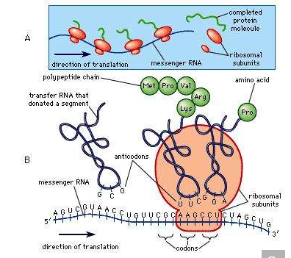

Synthesis of protein

Another crucial component of the translational process is transfer RNA (tRNA). The function of any one tRNA molecule is to bind to a designated amino acid and carry it to a ribosome, where the amino acid is added to the growing amino acid chain. Each amino acid has its own set of tRNA molecules that will bind only to that specific amino acid. A tRNA molecule is a single nucleotide chain with several helical regions and a loop containing three unpaired nucleotides, called an anticodon. The anticodon of any one tRNA fits perfectly into the mRNA codon that codes for the amino acid attached to that tRNA; for example, the mRNA codon UUU, which codes for the amino acid phenylalanine, will be bound by the anticodon AAA. Thus, any mRNA codon that happens to be on the ribosome at any one time will solicit the binding only of the tRNA with the appropriate anticodon, which will align the correct amino acid for addition to the chain. A tRNA molecule and its attached amino acid must bind to the ribosome as well as to the codon during this amino acid chain-elongation process. A ribosome has two tRNA binding sites; at the first site, one tRNA attaches to the amino acid chain, and at the second site, another tRNA carrying the next amino acid is attached. After attachment, the first tRNA departs and recycles, whereas the second tRNA is now left holding the amino acid chain. At this time the ribosome moves to the next codon, and the whole process is successively repeated along the length of the mRNA until a stop codon is reached, at which time the completed amino acid chain is released from the ribosome.

The amino acid chain then spontaneously folds to generate the three-dimensional shape necessary for its function. Each amino acid has its own special shape and pattern of electrical charges on its surface, and ultimately these are what determine the overall shape of the protein. The protein’s shape is stabilized by weak bonds that form between different parts of the chain. In some proteins, strong covalent bridges are formed between two cysteines at different sites in the chain. If the protein is composed of two or more amino acid chains, these also associate spontaneously and take on their most stable three-dimensional shape. For enzymes, shape determines the ability to bind to its specific substrate (i.e., the substance on which an enzyme acts). For structural proteins, the amino acid sequence determines whether it will be a filament, a sheet, a globule, or another shape.

**Gene mutation**

Given the complexity of DNA and the vast number of cell divisions that take place within the lifetime of a multicellular organism, copying errors are likely to occur. If unrepaired, such errors will change the sequence of the DNA bases and alter the genetic code. Mutation is the random process whereby genes change from one allelic form to another. Scientists who study mutation use the most common genotype found in natural populations, called the wild type, as the standard against which to compare a mutant allele. Mutation can occur in two directions; mutation from wild type to mutant is called a forward mutation, and mutation from mutant to wild type is called a back mutation or reversion.

**Mechanisms of mutation**

Mutations arise from changes to the DNA of a gene. These changes can be quite small, affecting only one nucleotide pair, or they can be relatively large, affecting hundreds or thousands of nucleotides. Mutations in which one base is changed are called point mutations—for example, substitution of the nucleotide pair AT by GC, CG, or TA. Base substitutions can have different consequences at the protein level. Some base substitutions are “silent,” meaning that they result in a new codon that codes for the same amino acid as the wild type codon at that position or a codon that codes for a different amino acid that happens to have the same properties as those in the wild type. Substitutions that result in a functionally different amino acid are called “missense” mutations; these can lead to alteration or loss of protein function. A more severe type of base substitution, called a “nonsense” mutation, results in a stop codon in a position where there was not one before, which causes the premature termination of protein synthesis and, more than likely, a complete loss of function in the finished protein.

Another type of point mutation that can lead to drastic loss of function is a frameshift mutation, the addition or deletion of one or more DNA bases. In a protein-coding gene, the sequence of codons starting with AUG and ending with a termination codon is called the reading frame. If a nucleotide pair is added to or subtracted from this sequence, the reading frame from that point will be shifted by one nucleotide pair, and all of the codons downstream will be altered. The result will be a protein whose first section (before the mutational site) is that of the wild type amino acid sequence, followed by a tail of functionally meaningless amino acids. Large deletions of many codons will not only remove amino acids from a protein but may also result in a frameshift mutation if the number of nucleotides deleted is not a multiple of three. Likewise, an insertion of a block of nucleotides will add amino acids to a protein and perhaps also have a frameshift effect.

A number of human diseases are caused by the expansion of a trinucleotide pair repeat. For example, fragile-X syndrome, the most common type of inherited mental retardation in humans, is caused by the repetition of up to 1,000 copies of a CGG repeat in a gene on the X chromosome.

The impact of a mutation depends upon the type of cell involved. In a haploid cell, any mutant allele will most likely be expressed in the phenotype of that cell. In a diploid cell, a dominant mutation will be expressed over the wild type allele, but a recessive mutation will remain masked by the wild type. If recessive mutations occur in both members of one gene pair in the same cell, the mutant phenotype will be expressed. Mutations in germinal cells (i.e., reproductive cells) may be passed on to successive generations. However, mutations in somatic (body) cells will exert their effect only on that individual and will not be passed on to progeny.

The impact of an expressed somatic mutation depends upon which gene has been mutated. In most cases, the somatic cell with the mutation will die, an event that is generally of little consequence in a multicellular organism. However, mutations in a special class of genes called proto-oncogenes can cause uncontrolled division of that cell, resulting in a group of cells that constitutes a cancerous tumour.

Mutations can affect gene function in several different ways. First, the structure and function of the protein coded by that gene can be affected. For example, enzymes are particularly susceptible to mutations that affect the amino acid sequence at their active site (i.e., the region that allows the enzyme to bind with its specific substrate). This may lead to enzyme inactivity; a protein is made, but it has no enzymatic function. Second, some nonsense or frameshift mutations can lead to the complete absence of a protein. Third, changes to the promoter region of the gene can result in gene malfunction by interfering with transcription. In this situation, protein production is either inhibited or it occurs at an inappropriate time because of alterations somewhere in the regulatory region. Fourth, mutations within introns that affect the specific nucleotide sequences that direct intron splicing may result in an mRNA that still contains an intron. When translated, this extra RNA will almost certainly be meaningless at the protein level, and its extra length will lead to a functionless protein. Any mutation that results in a lack of function for a particular gene is called a “null” mutation. Less-severe mutations are called “leaky” mutations because some normal function still “leaks through” into the phenotype.

Most mutations occur spontaneously and have no known cause. The synthesis of DNA is a cooperative venture of many different interacting cellular components, and occasionally mistakes occur that result in mutations. Like many chemical structures, the bases of DNA are able to exist in several conformations called isomers. The keto form of a DNA base is the normal form that gives the molecule its standard base-pairing properties. However, the keto form occasionally changes spontaneously to the enol form, which has different base-pairing properties. For example, the keto form of cytosine pairs with guanine (its normal pairing partner), but the enol form of cytosine pairs with adenine. During DNA replication, this adenine base will act as the template for thymine in the newly synthesized strand. Therefore, a CG base pair will have mutated to a TA base pair. If this change results in a functionally different amino acid, then a missense mutation may result. Another spontaneous event that can lead to mutation is depurination, the complete loss of a purine base (adenine or guanine) at some location in the DNA. The resulting gap can be filled by any base during subsequent replications.

Researchers have demonstrated that ionizing radiation, some chemicals, and certain viruses are capable of acting as mutagens—agents that can increase the rate at which mutations occur. Some mutagens have been implicated as a cause of cancer. For example, ultraviolet (UV) radiation from the sun is known to cause skin cancer, and cigarette smoke is a primary cause of lung cancer.

**Repair of mutation**

A variety of mechanisms exists for repairing copying errors caused by DNA damage. One of the best-studied systems is the repair mechanism for damage caused by ultraviolet radiation. Ultraviolet radiation joins adjacent thymines, creating thymine dimers, which, if not repaired, may cause mutations. Special repair enzymes either cut the bond between the thymines or excise the bonded dimer and replace it with two single thymines. If both of these repair methods fail, a third method allows the DNA replication process to bypass the dimer; however, it is this bypass system that causes most mutations because bases are then inserted at random opposite the thymine dimer. Xeroderma pigmentosum, a severe hereditary disease of humans, is caused by a mutation in a gene coding for one of the thymine dimer repair enzymes. Individuals with this disease are highly susceptible to skin cancer.

Reverse mutation from the aberrant state of a gene back to its normal, or wild type, state can result in a number of possible molecular changes at the protein level. True reversion is the reversal of the original nucleotide change. However, phenotypic reversion can result from changes that restore a different amino acid with properties identical to the original. Second-site changes within a protein can also restore normal function. For example, an amino acid change at a site different from that altered by the original mutation can sometimes interact with the amino acid at the first mutant site to restore a normal protein shape. Also, second-site mutations at other genes can act as suppressors, restoring wild type function. For example, mutations in the anticodon region of a tRNA gene can result in a tRNA that sometimes inserts an amino acid at an erroneous stop codon; if the original mutation is caused by a stop codon, which arrests translation at that point, then a tRNA anticodon change can insert an amino acid and allow translation to continue normally to the end of the mRNA. Alternatively, some mutations at separate genes open up a new biochemical pathway that circumvents the block of function caused by the original mutation.

**Regulation of gene expression**

Not all genes in a cell are active in protein production at any given time. Gene action can be switched on or off in response to the cell’s stage of development and external environment. In multicellular organisms, different kinds of cells express different parts of the genome. In other words, a skin cell and a muscle cell contain exactly the same genes, but the differences in structure and function of these cells result from the selective expression and repression of certain genes.

In prokaryotes and eukaryotes, most gene-control systems are positive, meaning that a gene will not be transcribed unless it is activated by a regulatory protein. However, some bacterial genes show negative control. In this case the gene is transcribed continuously unless it is switched off by a regulatory protein. An example of negative control in prokaryotes involves three adjacent genes used in the metabolism of the sugar lactose by E. coli. The part of the chromosome containing the genes concerned is divided into two regions, one that includes the structural genes (i.e., those genes that together code for protein structure) and another that is a regulatory region. This overall unit is called an operon. If lactose is not present in a cell, transcription of the genes that code for the lactose-processing enzymes—β-galactosidase, permease, and transacetylase—is turned off. This is achieved by a protein called the lac repressor, which is produced by the repressor gene and binds to a region of the operon called the operator. Such binding prevents RNA polymerase, which initially binds at the adjacent promoter, from moving into the coding region. If lactose enters the cell, it binds to the lac repressor and induces a change of shape in the repressor so that it can no longer bind to the DNA at the operon. Consequently, the RNA polymerase is able to travel from the promoter down the three adjacent protein-coding regions, making one continuous transcript. This three-gene transcript is subsequently translated into three separate proteins.

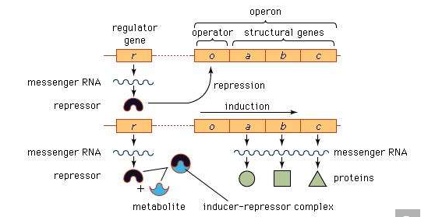

Model of the operon and its relation to the regulator gene.

Although the operon model has proved a useful model of gene regulation in bacteria, different regulatory mechanisms are employed in eukaryotes. First, there are no operons in eukaryotes, and each gene is regulated independently. Furthermore, the series of events associated with gene expression in higher organisms is much more complex than in prokaryotes and involves multiple levels of regulation.

In order for a gene to produce a functional protein, a complex series of steps must occur. Some type of signal must initiate the transcription of the appropriate region along the DNA, and, finally, an active protein must be made and sent to the appropriate location to perform its specific task. Regulation can be exerted at many different places along this pathway. The fundamental level of control is the rate of transcription. Transcription itself is also a complex process with many different components, and each one is a potential point of control. Regulatory proteins called activators or enhancers are needed for the transcription of genes at a specific time or in a certain cell. Thus, control is positive (not negative as in the lac operon) in that these proteins are necessary for the promotion of transcription. Activators bind to specific regions of the DNA in the upstream regulatory region, some very distant from the binding of the initiation complex.

Following the transcription of DNA into RNA, a process of editing and splicing takes place in which noncoding nucleotide sequences called introns are excised from the primary transcript, resulting in functional mRNA. For most genes this is a routine step in the production of mRNA, but in some genes there are alternative ways to splice the primary transcript, resulting in different mRNAs, which in turn result in different proteins.

Some genes are controlled at the translational and post-translational levels. One type of translational control is the storage of uncapped mRNA to meet future demands for protein synthesis. In other cases, control is exerted through the stability or instability of mRNA. The rate of translation of some mRNAs can also be regulated. Post-translationally, certain proteins (e.g., insulin) are synthesized in an inactive form and must be chemically modified to become active. Other proteins are targeted to specific locations inside the cell (e.g., mitochondria) by means of highly specific amino acid sequences at their ends, called leader sequences; when the protein reaches its correct site, the leader segment is cut off, and the protein begins to function. Post-translational control is also exerted through mRNA and protein degradation.

**Repetitive DNA**

One major difference between the genomes of prokaryotes and eukaryotes is that most eukaryotes contain repetitive DNA, with the repeats either clustered or spread out between the unique genes. There are several categories of repetitive DNA: (1) single copy DNA, which contains the structural genes (protein-coding sequences), (2) families of DNA, in which one gene somehow copies itself, and the repeats are located in small clusters (tandem repeats) or spread throughout the genome (dispersed repeats), and (3) satellite DNA, which contains short nucleotide sequences repeated as many as thousands of times. Such repeats are often found clustered in tandem near the centromeres (i.e., the attachment points for the nuclear spindle fibres that move chromosomes during cell division). Microsatellite DNA is composed of tandem repeats of two nucleotide pairs that are dispersed throughout the genome. Minisatellite DNA, sometimes called variable number tandem repeats (VNTRs), is composed of blocks of longer repeats also dispersed throughout the genome. There is no known function for satellite DNA, nor is it known how the repeats are created. There is a special class of relatively large DNA elements called transposons, which can make replicas of themselves that “jump” to different locations in the genome; most transposons eventually become inactive and no longer move, but, nevertheless, their presence contributes to repetitive DNA.

**Secretory vesicles**

The release of proteins or other molecules from a secretory vesicle is most often stimulated by a nervous or hormonal signal. For example, a nerve cell impulse triggers the fusion of secretory vesicles to the membrane at the nerve terminal, where the vesicles release neurotransmitters into the synaptic cleft (the gap between nerve endings). The action is one of exocytosis: the vesicle and the cell membrane fuse, allowing the proteins and glycoproteins in the vesicle to be released to the cell exterior.

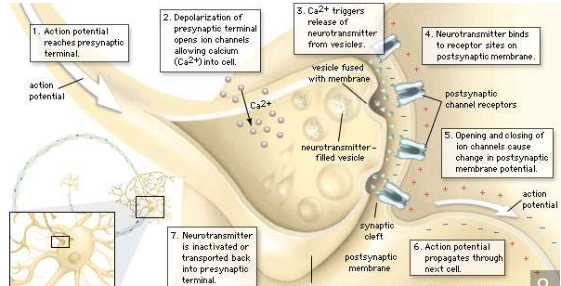

Chemical transmission of a nerve impulse at the synapseThe arrival of the nerve impulse at the presynaptic terminal stimulates the release of neurotransmitter into the synaptic gap. The binding of the neurotransmitter to receptors on the postsynaptic membrane stimulates the regeneration of the action potential in the postsynaptic neuron.

As secretory vesicles fuse with the cell membrane, the area of the cell membrane increases. Normal size is regained by the reuptake of membrane components through endocytosis. Regions bud in from the cell membrane and then fuse with internal membranes to effect recycling.

**Sorting of products by chemical receptors**

Not all proteins synthesized on the ER are destined for export. Many, such as the hydrolases in lysosomes, remain inside the cell; others become anchored in the membrane of internal organelles or in the cell membrane. It is presumed that each protein has some type of marker that fits a specific location in the cell.

Proteins synthesized on free ribosomes have segments that bind to specific receptors on the outer membrane of mitochondria, chloroplasts, or peroxisomes, allowing these proteins to be taken up only by these organelles. In the case of proteins synthesized in the RER, both the hydrolases destined for lysosomes and the secretory proteins are found initially in the same portion of the ER lumen. Studies have shown that these can be distinguished on the basis of their carbohydrate residues. The carbohydrate residues of lysosomal enzymes become modified in the cis-Golgi by the addition of certain phosphate groups. This critical modification allows the enzymes to bind to specific receptors on the membrane of the Golgi, which then directs them into vesicles leading to a lysosome rather than a secretory vesicle. In the lysosomes, proton pumps create an acidic environment that causes the release of the lysosomal enzyme from the membrane-bound receptors. Much of this sorting activity is mediated by coated vesicles containing the same fibrous outer protein, clathrin, used in endocytosis. These sorting vesicles also contain associated smaller proteins.

**The Nucleus**

The nucleus is the information centre of the cell and is surrounded by a nuclear membrane in all eukaryotic organisms. It is separated from the cytoplasm by the nuclear envelope, and it houses the double-stranded, spiral-shaped deoxyribonucleic acid (DNA) molecules, which contain the genetic information necessary for the cell to retain its unique character as it grows and divides.

The presence of a nucleus distinguishes the eukaryotic cells of multicellular organisms from the prokaryotic, one-celled organisms such as bacteria. In contrast to the higher organisms, prokaryotes do not have nuclei, so their DNA is maintained in the same compartment as their other cellular components.

The primary function of the nucleus is the expression of selected subsets of the genetic information encoded in the DNA double helix. Each subset of a DNA chain, called a gene, codes for the construction of a specific protein out of a chain of amino acids. Information in DNA is not decoded directly into proteins, however. First it is transcribed, or copied, into a range of messenger ribonucleic acid (mRNA) molecules, each of which encodes the information for one protein (or more than one protein in bacteria). The mRNA molecules are then transported through the nuclear envelope into the cytoplasm, where they are translated, serving as templates for the synthesis of specific proteins.

The nucleus must not only synthesize the mRNA for many thousands of proteins, but it must also regulate the amounts synthesized and supplied to the cytoplasm. Furthermore, the amounts of each type of mRNA supplied to the cytoplasm must be regulated differently in each type of cell. In addition to mRNA, the nucleus synthesizes and exports other classes of RNA involved in the mechanisms of protein synthesis.

**Structural organization of the nucleus**

**DNA packaging**

The nucleus of the average human cell is only 6 micrometres (6 × 10−6 metre) in diameter, yet it contains about 1.8 metres of DNA. This is distributed among 46 chromosomes, each consisting of a single DNA molecule about 40 mm (1.5 inches) long. The extraordinary packaging problem this poses can be envisaged by a scale model enlarged a million times. On this scale a DNA molecule would be a thin string 2 mm thick, and the average chromosome would contain 40 km (25 miles) of DNA. With a diameter of only 6 metres, the nucleus would contain 1,800 km (1,118 miles) of DNA.

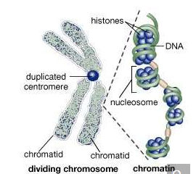

During the first stages of cell division, the recognizable double-stranded chromosome is formed by two tightly coiled DNA strands (chromatids) joined at a point called the centromere. During the middle stage of cell division, the centromere duplicates, and the chromatid pair separates. Following cell division, the separated chromatids uncoil; the loosely coiled DNA, wrapped around its associated proteins (histones) to form beaded structures called nucleosomes, is termed chromatin.

These contents must be organized in such a way that they can be copied into RNA accurately and selectively. DNA is not simply crammed or wound into the nucleus like a ball of string; rather, it is organized, by molecular interaction with specific nuclear proteins, into a precisely packaged structure. This combination of DNA with proteins creates a dense, compact fibre called chromatin. An extreme example of the ordered folding and compaction that chromatin can undergo is seen during cell division, when the chromatin of each chromosome condenses and is divided between two daughter cells

**Nucleosomes: the subunits of chromatin**

The compaction of DNA is achieved by winding it around a series of small proteins called histones. Histones are composed of positively charged amino acids that bind tightly to and neutralize the negative charges of DNA. There are five classes of histone. Four of them, called H2A, H2B, H3, and H4, contribute two molecules each to form an octamer, an eight-part core around which two turns of DNA are wrapped. The resulting beadlike structure is called the nucleosome. The DNA enters and leaves a series of nucleosomes, linking them like beads along a string in lengths that vary between species of organism or even between different types of cell within a species. A string of nucleosomes is then coiled into a solenoid configuration by the fifth histone, called H1. One molecule of H1 binds to the site at which DNA enters and leaves each nucleosome, and a chain of H1 molecules coils the string of nucleosomes into the solenoid structure of the chromatin fibre.

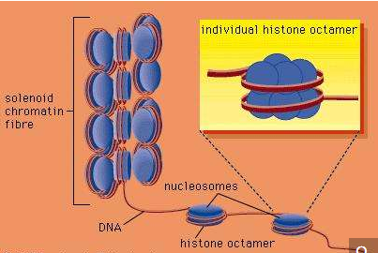

DNA wrapped around clusters of histone proteins to form nucleosomes, which can coil to form solenoids.

Nucleosomes not only neutralize the charges of DNA, but they have other consequences. First, they are an efficient means of packaging. DNA becomes compacted by a factor of six when wound into nucleosomes and by a factor of about 40 when the nucleosomes are coiled into a solenoid chromatin fibre. The winding into nucleosomes also allows some inactive DNA to be folded away in inaccessible conformations, a process that contributes to the selectivity of gene expression.

**Organization of chromatin fibre**

Several studies indicate that chromatin is organized into a series of large radial loops anchored to specific scaffold proteins. Each loop consists of a chain of nucleosomes and may be related to units of genetic organization. This radial arrangement of chromatin loops compacts DNA about a thousandfold. Further compaction is achieved by a coiling of the entire looped chromatin fibre into a dense structure called a chromatid, two of which form the chromosome. During cell division, this coiling produces a 10,000-fold compaction of DNA.

**The nuclear envelope**

The nuclear envelope is a double membrane composed of an outer and an inner phospholipid bilayer. The thin space between the two layers connects with the lumen of the rough endoplasmic reticulum (RER), and the outer layer is an extension of the outer face of the RER.

The inner surface of the nuclear envelope has a protein lining called the nuclear lamina, which binds to chromatin and other contents of the nucleus. The entire envelope is perforated by numerous nuclear pores. These transport routes are fully permeable to small molecules up to the size of the smallest proteins, but they form a selective barrier against movement of larger molecules. Each pore is surrounded by an elaborate protein structure called the nuclear pore complex, which selects molecules for entrance into the nucleus. Entering the nucleus through the pores are the nucleotide building blocks of DNA and RNA, as well as adenosine triphosphate, which provides the energy for synthesizing genetic material. Histones and other large proteins must also pass through the pores. These molecules have special amino acid sequences on their surface that signal admittance by the nuclear pore complexes. The complexes also regulate the export from the nucleus of RNA and subunits of ribosomes.

DNA in prokaryotes is also organized in loops and is bound to small proteins resembling histones, but these structures are not enclosed by a nuclear membrane.

**Genetic organization of the nucleus**

**The structure of DNA**

Several features are common to the genetic structure of most organisms. First is the double-stranded DNA. Each strand of this molecule is a series of nucleotides, and each nucleotide is composed of a sugar-phosphate compound attached to one of four nitrogen-containing bases. The sugar-phosphate compounds link together to form the backbone of the strand. Each of the bases strung along the backbone is chemically attracted to a corresponding base on the parallel strand of the DNA molecule. This base pairing joins the two strands of the molecule much as rungs join the two sides of a ladder, and the chemical bonding of the base pairs twists the doubled strands into a spiral, or helical, shape.

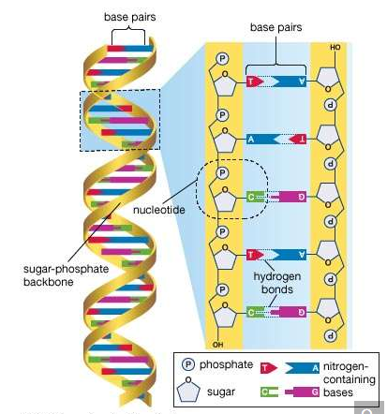

DNA molecule

The four nucleotide bases are adenine, cytosine, guanine, and thymine. DNA is composed of millions of these bases strung in an apparently limitless variety of sequences. It is in the sequence of bases that the genetic information is contained, each sequence determining the sequence of amino acids to be connected into proteins. A nucleotide sequence sufficient to encode one protein is called a gene. Genes are interspersed along the DNA molecule with other sequences that do not encode proteins. Some of these so-called untranslated regions regulate the activity of the adjacent genes, for example, by marking the points at which enzymes begin and cease transcribing DNA into RNA.

**Rearrangement and modification of DNA**

Rearrangements and modifications of the nucleotide sequences in DNA are exceptions to the rules of genetic expression and sometimes cause significant changes in the structure and function of cells. Different cells of the body owe their specialized structures and functions to different genes. This does not mean that the set of genetic information varies among the cells of the body. Indeed, for each cell the entire DNA content of the chromosomes is usually duplicated exactly from generation to generation, and, in general, the genetic content and arrangement is strikingly similar among different cell types of the same organism. As a result, the differentiation of cells can occur without the loss or irreversible inactivation of unnecessary genes, an observation that is reinforced by the presence of specific genes in a range of adult tissues. For example, normal copies of the genes encoding hemoglobin are present in the same numbers in red blood cells, which make hemoglobin, as in a range of other types of cells, which do not.

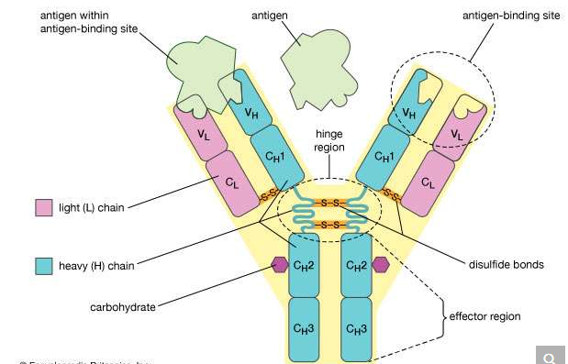

The structure of an antibody molecule represents the dramatic rearrangements of DNA that occur in the immune systems of mammals. Each antibody contains a light chain and a heavy chain that are encoded by different segments of DNA. These segments are subject to considerable variation and are thus able to produce many different antibodies.

Despite the general uniformity of genetic content in all the cells of an organism, studies have shown a few clear examples in some organisms of programmed, reversible change in the DNA of developing tissues. One of the most dramatic rearrangements of DNA occurs in the immune systems of mammals. The body’s defense against invasion by foreign organisms involves the synthesis of a vast range of antibodies by lymphocytes (a type of white blood cell). Antibodies are proteins that bind to specific invading molecules or organisms and either inactivate them or signal their destruction. The binding sites on each antibody molecule are formed by one light and one heavy amino acid chain, which are encoded by different segments of the DNA in the lymphocyte nucleus. These DNA segments undergo considerable rearrangements, resulting in the synthesis of a great variety of antibodies. Some invasive organisms, such as trypanosome parasites, which cause sleeping sickness, go to great lengths to rearrange their own DNA to evade the versatility of their hosts’ antibody production. The parasites are covered by a thick coat of glycoprotein (a protein with sugars attached). Given time, host organisms can overcome infection by producing antibodies to the parasites’ glycoprotein coat, but this reaction is anticipated and evaded by the selective rearrangement of the trypanosomes’ DNA encoding the glycoprotein, thus constantly changing the surface presented to the hosts’ immune system.

Careful comparisons of gene structure have also revealed epigenetic modifications, heritable changes that occur on the sugar-phosphate side of bases in the DNA and thus do not cause rearrangements in the DNA sequence itself. An example of an epigenetic modification involves the addition of a methyl group to cytosine bases. This appears to cause the inactivation of genes that do not need to be expressed in a particular type of cell. An important feature of the methylation of cytosine lies in its ability to be copied, so that methyl groups in a dividing cell’s DNA will result in methyl groups in the same positions in the DNA of both daughter cells.

**Genetic expression through RNA**

The transcription of the genetic code from DNA to RNA, and the translation of that code from RNA into protein, exerts the greatest influence on the modulation of genetic information. The process of genetic expression takes place over several stages, and at each stage is the potential for further differentiation of cell types.

As explained above, genetic information is encoded in the sequences of the four nucleotide bases making up a DNA molecule. One of the two DNA strands is transcribed exactly into messenger RNA (mRNA), with the exception that the thymine base of DNA is replaced by uracil. RNA also contains a slightly different sugar component (ribose) from that of DNA (deoxyribose) in its connecting sugar-phosphate chain. Unlike DNA, which is stable throughout the cell’s life and of which individual strands are even passed on to many cell generations, RNA is unstable. It is continuously broken down and replaced, enabling the cell to change its patterns of protein synthesis.

Apart from mRNA, which encodes proteins, other classes of RNA are made by the nucleus. These include ribosomal RNA (rRNA), which forms part of the ribosomes and is exported to the cytoplasm to help translate the information in mRNA into proteins. Ribosomal RNA is synthesized in a specialized region of the nucleus called the nucleolus, which appears as a dense area within the nucleus and contains the genes that encode rRNA. This is also the site of assembly of ribosome subunits from rRNA and ribosomal proteins. Ribosomal proteins are synthesized in the cytoplasm and transported to the nucleus for subassembly in the nucleolus. The subunits are then returned to the cytoplasm for final assembly. Another class of RNA synthesized in the nucleus is transfer RNA (tRNA), which serves as an adaptor, matching individual amino acids to the nucleotide triplets of mRNA during protein synthesis.

**RNA synthesis**

The synthesis of RNA is performed by enzymes called RNA polymerases. In higher organisms there are three main RNA polymerases, designated I, II, and III (or sometimes A, B, and C). Each is a complex protein consisting of many subunits. RNA polymerase I synthesizes three of the four types of rRNA (called 18S, 28S, and 5.8S RNA); therefore it is active in the nucleolus, where the genes encoding these rRNA molecules reside. RNA polymerase II synthesizes mRNA, though its initial products are not mature RNA but larger precursors, called heterogeneous nuclear RNA, which are completed later. The products of RNA polymerase III include tRNA and the fourth RNA component of the ribosome, called 5S RNA.

All three polymerases start RNA synthesis at specific sites on DNA and proceed along the molecule, linking selected nucleotides sequentially until they come to the end of the gene and terminate the growing chain of RNA. Energy for RNA synthesis comes from high-energy phosphate linkages contained in the nucleotide precursors of RNA. Each unit of the final RNA product is essentially a sugar, a base, and one phosphate, but the building material consists of a sugar, a base, and three phosphates. During synthesis two phosphates are cleaved and discarded for each nucleotide that is incorporated into RNA. The energy released from the phosphate bonds is used to link the nucleotides. The crucial feature of RNA synthesis is that the sequence of nucleotides joined into a growing RNA chain is specified by the sequence of nucleotides in the DNA template: each adenine in DNA specifies uracil in RNA, each cytosine specifies guanine, each guanine specifies cytosine, and each thymine in DNA specifies adenine. In this way the information encoded in each gene is transcribed into RNA for translation by the protein-synthesizing machinery of the cytoplasm.

In addition to specifying the sequence of amino acids to be polymerized into proteins, the nucleotide sequence of DNA contains supplementary information. For example, short sequences of nucleotides determine the initiation site for each RNA polymerase, specifying where and when RNA synthesis should occur. In the case of RNA polymerases I and II, the sequences specifying initiation sites lie just ahead of the genes. In contrast, the equivalent information for RNA polymerase III lies within the gene—that is, within the region of DNA to be copied into RNA. The initiation site on a segment of DNA is called a promoter. The promoters of different genes have some nucleotide sequences in common, but they differ in others. The differences in sequence are recognized by specific proteins called transcription factors, which are necessary for the expression of particular types of genes. The specificity of transcription factors contributes to differences in the gene expression of different types of cells.

**Processing of mRNA**

During and after synthesis, mRNA precursors undergo a complex series of changes before the mature molecules are released from the nucleus. First, a modified nucleotide is added to the start of the RNA molecule by a reaction called capping. This cap later binds to a ribosome in the cytoplasm. The synthesis of mRNA is not terminated simply by the RNA polymerase’s detachment from DNA, but by chemical cleavage of the RNA chain. Many (but not all) types of mRNA have a simple polymer of adenosine residues added to their cleaved ends.

In addition to these modifications of the termini, startling discoveries in 1977 revealed that portions of newly synthesized RNA molecules are cut out and discarded. In many genes, the regions coding for proteins are interrupted by intervening sequences of nucleotides called introns. These introns must be excised from the RNA copy before it can be released from the nucleus as a functional mRNA. The number and size of introns within a gene vary greatly, from no introns at all to more than 50. The sum of the lengths of these intervening sequences is sometimes longer than the sum of the regions coding for proteins.

The removal of introns, called RNA splicing, appears to be mediated by small nuclear ribonucleoprotein particles (snRNP’s). These particles have RNA sequences that are complementary to the junctions between introns and adjacent coding regions. By binding to the junction ends, an snRNP twists the intron into a loop. It then excises the loop and splices the coding regions.

**Regulation of genetic expression**

Although all the cell nuclei of an organism generally carry the same genes, there are conspicuous differences between the specialized cell types of the body. The source of these differences lies not so much in the occasional modification of DNA, as outlined above, but in the selective expression of DNA through RNA; in particular, it can be traced to processes regulating the amounts and activities of mRNA both during and after its synthesis in the nucleus.

**Regulation of RNA synthesis**

The first level of regulation is mediated by variations in chromatin structure. In order to be transcribed, a gene must be assembled into a structurally distinct form of active chromatin. A second level of regulation is achieved by varying the frequency with which a gene in the active conformation is transcribed into RNA by an RNA polymerase. There is evidence for regulation of RNA synthesis at both these levels—for example, in response to hormone induction. At both levels, protein factors are believed to perform the regulation—for example, by binding to special promoter DNA regions flanking the transcribed gene.

**Regulation of RNA after synthesis**

After synthesis, RNA molecules undergo selective processing, which results in the export of only a subpopulation of RNA molecules to the cytoplasm. Furthermore, the stability in the cytoplasm of a particular type of mRNA can be regulated. For example, the hormone prolactin increases synthesis of milk proteins in tissue by causing a twofold rise in the rate of mRNA synthesis; but it also causes a 17-fold rise in mRNA lifetime, so that in this case the main cause of increased protein synthesis is the prolonged availability of mRNA. Conversely, there is evidence for selective destabilization of some mRNA—such as histone mRNA, which is rapidly broken down when DNA replication is interrupted. Finally, there are many examples of selective regulation of the translation of mRNA into protein.

**The Mitochondrion And The Chloroplast**

Mitochondria and chloroplasts are the powerhouses of the cell. Mitochondria appear in both plant and animal cells as elongated cylindrical bodies, roughly one micrometre in length and closely packed in regions actively using metabolic energy. Mitochondria oxidize the products of cytoplasmic metabolism to generate adenosine triphosphate (ATP), the energy currency of the cell. Chloroplasts are the photosynthetic organelles in plants and some algae. They trap light energy and convert it partly into ATP but mainly into certain chemically reduced molecules that, together with ATP, are used in the first steps of carbohydrate production. Mitochondria and chloroplasts share a certain structural resemblance, and both have a somewhat independent existence within the cell, synthesizing some proteins from instructions supplied by their own DNA.

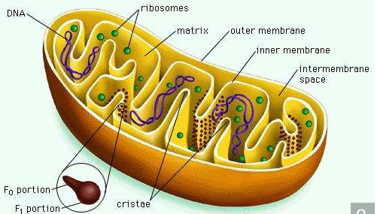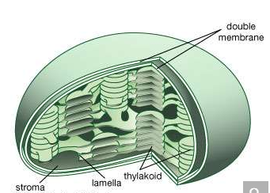

Mitochondrial and chloroplastic structure

Both organelles are bounded by an external membrane that serves as a barrier by blocking the passage of cytoplasmic proteins into the organelle. An inner membrane provides an additional barrier that is impermeable even to small ions such as protons. The membranes of both organelles have a lipid bilayer construction. Located between the inner and outer membranes is the intermembrane space.

In mitochondria the inner membrane is elaborately folded into structures called cristae that dramatically increase the surface area of the membrane. In contrast, the inner membrane of chloroplasts is relatively smooth. However, within this membrane is yet another series of folded membranes that form a set of flattened, disklike sacs called thylakoids. The space enclosed by the inner membrane is called the matrix in mitochondria and the stroma in chloroplasts. Both spaces are filled with a fluid containing a rich mixture of metabolic products, enzymes, and ions. Enclosed by the thylakoid membrane of the chloroplast is the thylakoid space. The extraordinary chemical capabilities of the two organelles lie in the cristae and the thylakoids. Both membranes are studded with enzymatic proteins either traversing the bilayer or dissolved within the bilayer. These proteins contribute to the production of energy by transporting material across the membranes and by serving as electron carriers in important oxidation-reduction reactions.

**Metabolic functions**

Crucial to the function of mitochondria and chloroplasts is the chemistry of the oxidation-reduction, or redox, reaction. This controlled burning of material comprises the transfer of electrons from one compound, called the donor, to another, called the acceptor. All compounds taking part in redox reactions are ranked in a descending scale according to their ability to act as electron donors. Those higher in the scale donate electrons to their fellows lower down, which have a lesser tendency to donate, but a correspondingly greater tendency to accept, electrons. Each acceptor in turn donates electrons to the next compound down the scale, forming a donor-acceptor chain extending from the greatest donating ability to the least.

At the top of the scale is hydrogen, the most abundant element in the universe. The nucleus of a hydrogen atom is composed of one positively charged proton; around the nucleus revolves one negatively charged electron. In the atmosphere two hydrogen atoms join to form a hydrogen molecule (H2). In solution the two atoms pull apart, dissociating into their constituent protons and electrons. In the redox reaction the electrons are passed from one reactant to another. The donation of electrons is called oxidation, and the acceptance is called reduction—hence the descriptive term oxidation-reduction, indicating that one action never takes place without the other.

A hydrogen atom has a great tendency to transfer an electron to an acceptor. An oxygen atom, in contrast, has a great tendency to accept an electron. The burning of hydrogen by oxygen is, chemically, the transfer of an electron from each of two hydrogen atoms to oxygen, so that hydrogen is oxidized and oxygen reduced. The reaction is extremely exergonic; i.e., it liberates much free energy as heat. This is the reaction that takes place within mitochondria but is so controlled that the heat is liberated not at once but in a series of steps. The free energy, harnessed by the organelle, is coupled to the synthesis of ATP from adenosine diphosphate (ADP) and inorganic phosphate (Pi).

An analogy can be drawn between this controlled reaction and the flow of river water down a lock system. Without the locks, water flow would be rapid and uncontrolled, and no ship could safely ply the river. The locks force water to flow in small controlled steps conducive to safe navigation. But there is more to a lock system than this. The flow of water down the locks can also be harnessed to raise a ship from a lower to a higher level, with the water rather than the ship expending the energy. In mitochondria the burning of hydrogen is broken into a series of small indirect steps following the flow of electrons along a chain of donor-acceptors. Energy is funneled into the chemical bonding of ADP and Pi, raising the free energy of these two compounds to the high level of ATP.

**The mitochondrion**

**Formation of the electron donors NADH and FADH2**

Through a series of metabolic reactions carried out in the matrix, the mitochondrion converts products of the cell’s initial metabolism of fats, amino acids, and sugars into the compound acetyl coenzyme A. The acetate portion of this compound is then oxidized in a chain reaction called the tricarboxylic acid cycle. At the end of this cycle the carbon atoms yield carbon dioxide and the hydrogen atoms are transferred to the cell’s most important hydrogen acceptors, the coenzymes nicotinamide adenine dinucleotide (NAD+) and flavin adenine dinucleotide (FAD), yielding NADH and FADH2. It is the subsequent oxidation of these hydrogen acceptors that leads eventually to the production of ATP.

NADH and FADH2 are compounds of high electron-donating capacity. Were they to transfer their electrons directly to oxygen, the resulting combustion would release a lethal burst of heat energy. Instead, the energy is released in a series of electron donor-acceptor reactions carried out within the cristae of the mitochondrion by a number of proteins and coenzymes that make up the electron-transport, or respiratory, chain.

**The electron-transport chain**

The proteins of this chain are embedded in the cristae membrane, actually traversing the lipid bilayer and protruding from the inner and outer surfaces. The coenzymes are dissolved in the lipid and diffuse through the membrane or across its surface. The proteins are arranged in three large complexes, each composed of a number of polypeptide chains. Each complex is, to continue the hydraulic analogy, a lock in the waterfall of the electron flow and the site at which energy from the overall redox reaction is tapped. The first complex, NADH dehydrogenase, accepts a pair of electrons from the primary electron donor NADH and is reduced in the process. It in turn donates these electrons to the coenzyme ubiquinone, a lipid-soluble molecule composed of a substituted benzene ring attached to a hydrocarbon tail. Ubiquinone, diffusing through the lipid of the cristae membrane, reaches the second large complex of the electron-transport chain, the b-c2 complex, which accepts the electrons, oxidizing ubiquinone and being itself reduced. (This complex can also accept electrons from the second primary electron donor, FADH2, a molecule below NADH in the electron-donating scale.) The b-c2 complex transfers the pair of electrons to cytochrome c, a small protein situated on the outer surface of the cristae membrane. From cytochrome c, electrons pass (four at a time) to the third large complex, cytochrome oxidase, which, in the final step of the chain, transfers the four electrons to two oxygen atoms and two protons, generating two water molecules.

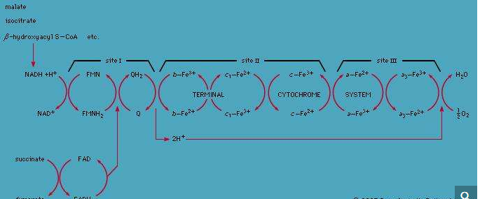

The electron-transport chain embedded in the inner membrane of a mitochondrion is made up of a series of electron donors and electron acceptors. The transport of electrons begins with the acceptance of electrons by NADH dehydrogenase from NADH. The electrons are then passed to ubiquinone (coenzyme Q; site I), which carries them to the b-c2 complex. The electrons are then transferred to cytochrome c (site II), to cytochrome oxidase (site III), and finally to oxygen.

The electron-transport chain embedded in the inner membrane of a mitochondrion is made up of a series of electron donors and electron acceptors. The transport of electrons begins with the acceptance of electrons by NADH dehydrogenase from NADH. The electrons are then passed to ubiquinone (coenzyme Q; site I), which carries them to the b-c2 complex. The electrons are then transferred to cytochrome c (site II), to cytochrome oxidase (site III), and finally to oxygen.

This transfer of electrons, from member to member of the electron-transport chain, provides energy for the synthesis of ATP through an indirect route. At the beginning of the electron-transport chain, NADH and FADH2 split hydrogen atoms into protons and electrons, transferring the electrons to the next protein complex and releasing the protons into the mitochondrial matrix. When each protein complex in turn transfers the electrons down the chain, it uses the energy released in this process to pump protons across the inner membrane into the intermembrane space. (For the dynamics of this pumping action, see above Transport across the membrane.) This transport of positively charged protons into the intermembrane space, opposite the negatively charged electrons in the matrix, creates an electrical potential that tends to draw the protons back across the membrane. A high concentration of protons outside the membrane also creates the conditions for their diffusion back into the matrix. However, as explained above, the inner membrane is extremely impermeable to protons. In order for the protons to flow back down the electrochemical gradient, they must traverse the membrane through transport molecules similar to the protein complexes of the electron-transfer chain. These molecules are the so-called F1F0ATPase, a complex protein that, transporting protons back into the matrix, uses the energy released to synthesize ATP. The protons then join the electrons and oxygen atoms to form water. (For further discussion of ATP production, see above Coupled chemical reactions.)

This complex chain of events, the basis of the cell’s ability to derive ATP from metabolic oxidation, was conceived in its entirety by the British biochemist Peter Mitchell in 1961. The years following the announcement of his chemiosmotic theory saw its ample substantiation and revealed its profound implications for cell biology.

**The chemiosmotic theory**

The four postulates of the chemiosmotic theory, including examples of their experimental substantiation, are as follows:

(1) The inner mitochondrial membrane is impermeable to protons, hydroxide ions, and other cations and anions. This postulate was validated when it was shown that substances allowing protons to flow readily across mitochondrial membranes uncouple oxidative electron transport from ATP production.

(2) Transfer of electrons down the electron-transport chain brings about pumping of protons across the inner membrane, from matrix to intermembrane space. This was demonstrated in laboratory experiments that reconstituted the components of the electron-transport chain in artificial membrane vesicles. The stimulation of electron transport caused a measurable buildup of protons within the vesicle.

(3) The flow of protons down a built-up electrochemical gradient occurs through a proton-dependent ATPase, so that ATP is synthesized from ADP and Pi whenever protons move through the enzyme. This hypothesis was confirmed by the discovery of what came to be known as the F1F0ATPase. Shaped like a knob attached to the membrane by a narrow stalk, F1F0ATPase covers the inner surface of the cristae. Its stalk (the F0 portion) penetrates the lipid bilayer of the inner membrane and is capable of catalyzing the transport of protons. The knob (the F1 portion) is capable of synthesizing as well as splitting, or hydrolyzing, ATP. F1F0ATPase is therefore reversible, either using the energy of proton diffusion to combine ADP and Pi or using the energy of ATP hydrolysis to pump protons out of the matrix.

(4) The inner membrane of the mitochondrion possesses a complement of proteins that brings about the transport of essential metabolites. Numerous carrier systems have been demonstrated to transport into the mitochondrion the products of metabolism that are transformed into substrates for the electron-transport chain. Best known is the ATP-ADP exchange carrier of the inner membrane. Neither ATP nor ADP, being large charged molecules, can cross the membrane unaided, but ADP must enter and ATP must leave the mitochondrial matrix in order for ATP synthesis to continue. A single protein conducts the counter-transport of ATP against ADP, the energy released by the flow of ATP down its concentration gradient being coupled to the pumping of ADP up its gradient and into the mitochondrion.

**The chloroplast**

**Trapping of light**

Light travels as packets of energy known as photons and is absorbed in this form by light-absorbing chlorophyll molecules embedded in the thylakoid membrane of the chloroplast. The chlorophyll molecules are grouped into antenna complexes, clusters of several hundred molecules that are anchored onto the thylakoid membrane by special proteins. Within each antenna complex is a specialized set of proteins and chlorophyll molecules that form a reaction centre. Photons absorbed by the other chlorophylls of the antenna are funneled into the reaction centre. The energy of the photon is absorbed by an electron of the reaction centre molecule in sufficient quantity to enable its acceptance by a nearby coenzyme, which cannot accept electrons at low energy levels. This coenzyme has a high electron-donor capability; it initiates the transfer of the electron down an electron-transport chain similar to that of the mitochondrion. Meanwhile, the loss of the negatively charged electron leaves a positively charged “hole” in the reaction centre chlorophyll molecule. This hole is filled by the enzymatic splitting of water into molecular oxygen, protons, and electrons and the transfer of an electron to the chlorophyll. The oxygen is released by the chloroplast, making its way out of the plant and into the atmosphere. The protons, in a process similar to that in the mitochondrion, are pumped through the thylakoid membrane and into the thylakoid space. Their facilitated diffusion back into the stroma through proteins embedded in the membrane powers the synthesis of ATP. This part of the photosynthetic process is called photosystem II.

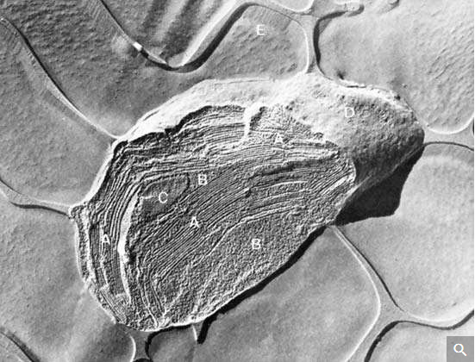

Electron micrograph of an isolated spinach chloroplast.

Courtesy of the Lawrence Berkeley National Laboratory, University of California, Berkeley

At the end of the electron-transport chain in the thylakoid membrane is another reaction centre molecule. The electron is again energized by photons and then transported down another chain, which makes up photosystem I. This system uses the energy released in electron transfer to join a proton to nicotinamide adenine dinucleotide phosphate (NADP+), a phosphorylated derivative of NAD+, forming NADPH. NADPH is a high-energy electron donor that, with ATP, fuels the conversion of carbon dioxide into the carbohydrate foods of the plant cell.

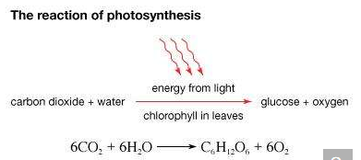

In photosynthesis, plants consume carbon dioxide and water and produce glucose and oxygen. Energy for this process is provided by light, which is absorbed by pigments, primarily chlorophyll. Chlorophyll is the pigment that gives plants their green colour.

**Fixation of carbon dioxide**

NADPH remains within the stroma of the chloroplast for use in the fixation of carbon dioxide (CO2) during the Calvin cycle. In a complex cycle of chemical reactions, CO2 is bound to a five-carbon ribulose biphosphate compound. The resulting six-carbon intermediate is then split into three-carbon phosphoglycerate. With energy supplied by the breakdown of NADPH and ATP, this compound is eventually formed into glyceraldehyde 3-phosphate, an important sugar intermediate of metabolism. One glyceraldehyde molecule is exported from the chloroplast, for further conversion in the cytoplasm, for every five that undergo an ATP-powered re-formation into the five-carbon ribulose biphosphate. In this way three molecules of CO2 yield one molecule of glyceraldehyde 3-phosphate, while the entire fixation cycle hydrolyzes nine molecules of ATP and oxidizes six molecules of NADPH.

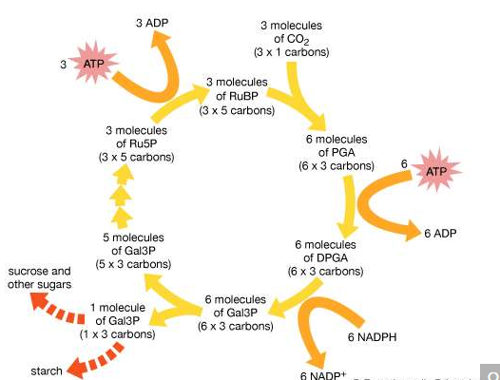

Pathway of carbon dioxide fixation and reduction in photosynthesis, the Calvin cycle. The diagram represents one complete turn of the cycle, with the net production of one molecule of glyceraldehyde-3-phosphate (Gal3P). This three-carbon sugar phosphate usually is converted to either sucrose or starch.

**Evolutionary origins**

**The mitochondrion and chloroplast as independent entities**

In addition to their remarkable metabolic capabilities, both mitochondria and chloroplasts synthesize on their own a number of proteins and lipids necessary for their structure and activity. Not only do they contain the machinery necessary for this, but they also possess the genetic material to direct it. DNA within these organelles has a circular structure reminiscent of prokaryotic, not eukaryotic, DNA. Also as in prokaryotes, the DNA is not associated with histones. Along with the DNA are protein-synthesizing ribosomes, of prokaryotic rather than eukaryotic size.

Only a small portion of the mitochondrion’s total number of proteins is synthesized within the organelle. Numerous proteins are encoded and made in the cytoplasm specifically for export into the mitochondrion. The mitochondrial DNA itself encodes only 13 different proteins. The proteins that contain subunits synthesized within the mitochondrion often also possess subunits synthesized in the cytoplasm. Mitochondrial and chloroplastic proteins synthesized in the cytoplasm have to enter the organelle by a complex process, crossing both the outer and the inner membranes. These proteins contain specific arrangements of amino acids known as leader sequences that are recognized by receptors on the outer membranes of the organelles. The proteins are then guided through membrane channels in an energy-requiring process.

**The endosymbiont hypothesis**

Mitochondria and chloroplasts are self-dividing; they contain their own DNA and protein-synthesizing machinery, similar to that of prokaryotes. Chloroplasts produce ATP and trap photons by mechanisms that are complex and yet similar to those of certain prokaryotes. These phenomena have led to the theory that the two organelles are direct descendants of prokaryotes that entered primitive nucleated cells. Among billions of such events, a few could have led to the development of stable, symbiotic associations between nucleated hosts and prokaryotic parasites. The hosts would provide the parasites with a stable osmotic environment and easy access to nutrients, and the parasites would repay the hosts by providing an oxidative ATP-producing system or a photosynthetic energy-producing reaction.

**The Cytoskeleton**

The cytoskeleton is the name given to the fibrous network formed by different types of long protein filaments present throughout the cytoplasm of eukaryotic cells (cells containing a nucleus). The filaments of the cytoskeleton create a scaffold, or framework, that organizes other cell constituents and maintains the shape of the cell. In addition, some filaments cause coherent movements, both of the cell itself and of its internal organelles. Prokaryotic (nonnucleated) cells, which are generally much smaller than eukaryotic cells, contain a unique related set of filaments but, with few exceptions, do not possess true cytoskeletons. Their shapes and the shapes of certain eukaryotes, primarily yeast and other fungi, are determined by the rigid cell wall on the outside of the cell.

Four major types of cytoskeletal filaments are commonly recognized: actin filaments, microtubules, intermediate filaments, and septins. Actin filaments and microtubules are dynamic structures that continuously assemble and disassemble in most cells. Intermediate filaments are stabler and seem to be involved mainly in reinforcing cell structures, especially the position of the nucleus and the junctions that connect cells. Septins are involved in cell division and have been implicated in other cell functions. A wide variety of accessory proteins works in concert with each type of filament, linking filaments to one another and to the cell membrane and helping to form the networks that endow the cytoskeleton with its unique functions. Many of these accessory proteins have been characterized, revealing a rich diversity in the structure and function of the cytoskeleton.

**Extranuclear DNA**

All of the genetic information in a cell was initially thought to be confined to the DNA in the chromosomes of the cell nucleus. It is now known that small circular chromosomes, called extranuclear, or cytoplasmic, DNA, are located in two types of organelles found in the cytoplasm of the cell. These organelles are the mitochondria in animal and plant cells and the chloroplasts in plant cells. Chloroplast DNA (cpDNA) contains genes that are involved with aspects of photosynthesis and with components of the special protein-synthesizing apparatus that is active within the organelle. Mitochondrial DNA (mtDNA) contains some of the genes that participate in the conversion of the energy of chemical bonds into the energy currency of the cell—a chemical called adenosine triphosphate (ATP)—as well as genes for mitochondrial protein synthesis.

The cells of several groups of organisms contain small extra DNA molecules called plasmids. Bacterial plasmids are circular DNA molecules; some carry genes for resistance to various agents in the environment that would be toxic to the bacteria (e.g., antibiotics). Many fungi and some plants possess plasmids in their mitochondria; most of these are linear DNA molecules carrying genes that seem to be relevant only to the propagation of the plasmid and not the host cell.

**Heredity And Evolution**

At the centre of the theory of evolution as proposed by Charles Darwin and Alfred Russell Wallace were the concepts of variation and natural selection. Hereditary variants were thought to arise naturally in populations, and then these were either selected for or against by the contemporary environmental conditions. In this way, subsequent generations either became enriched or impoverished for specific variant types. Over the long term, the accumulation of such changes in populations could lead to the formation of new species and higher taxonomic categories. However, although hereditary change was basic to the theory, in the 19th-century world of Darwin and Wallace, the fundamental unit of heredity—the gene—was unknown. The birth and proliferation of the science of genetics in the 20th century after the discovery of Mendel’s laws made it possible to consider the process of evolution by natural selection in terms of known genetic processes.

**Population genetics**

Because the processes of variation and selection take place at the population level, the basic theory of the genetics of evolutionary change is contained in the general area known as population genetics.

A simple way of viewing evolutionary change at the genotypic level would be to invent some hypothetical ancestral genotype, such as AAbbccDDEE, and an “evolved” derivative, such as aaBBccddee. (For illustrative purposes, only five genes are used, and these are assumed to be all homozygous.) Also, for simplicity it can be assumed that in both the ancestral and the evolved populations all individuals are identical. Clearly for all the genes except cc, a new allele completely replaces the original allele, and the new alleles can be either dominant or recessive. For example, in the case of the first gene, in the ancestral population all alleles are A, and in the evolved population all are a. For a to replace A, the population must go through stages in which there are mixtures of A and a alleles present in the population at the same time. In population genetics, allele frequency is the measurement of the commonness of an allele. The convention is to let the frequency of a dominant allele be p and that of a recessive allele q. Both are generally expressed as decimal fractions. In the above example, p changes from 1 to 0, and q changes from 0 to 1. Since there are only two alleles in this example, p + q must always equal 1. In the intermediate stages, there must be times when there are intermediate allele frequencies, for example when p = 0.4 and q = 0.6.

What can be said about genotype frequencies in the intermediate populations? In the ancestral and derived populations there must have been the following genotypic frequencies:

Ancestral AA = 1, Aa = 0, aa = 0

Evolved AA = 0, Aa = 0, aa = 1

Intuitively it seems that, in the intermediate stages, there must be more-complex proportions, including some heterozygotes. One possible intermediate stage is as follows:

AA = 0.30, Aa = 0.20, aa = 0.50

The allele frequencies at such an intermediate stage can be calculated by “adding up” the alleles. Hence, the frequency of A will be 0.30 plus 1/2 of 0.20 because the heterozygotes only carry one A allele. This is written

p = 0.30 + 0.20/2 = 0.40

Similarly, q = 0.50 + 0.20/2= 0.60

(Noting these values for p and q, it is possible that this could have been the population discussed earlier, in which these specific values for p and q were hypothesized.)

In general, if D = frequency of homozygous dominants, R = frequency of homozygous recessives, and H = frequency of heterozygotes, then

p = D + H/2

and

q = R + H/2

This section has shown the importance of the concepts of allele frequency and genotype frequency in describing the genetic structure of populations. Of these, allele frequency is the simpler descriptor, and it forms the central tool of population genetics. Hence, the genetic basis of evolutionary change at the population level is described in terms of changes of allele frequencies.

**Hardy-Weinberg equilibrium**

It is a curious fact that populations show no inherent tendency to change allele or genotype frequencies. In the absence of selection or any of the other forces that can drive evolution, a population with given values of p and q will settle into a special stable set of genotypic proportions called a Hardy-Weinberg equilibrium. This principle was first realized by Godfrey Harold Hardy and Wilhelm Weinberg in 1908. The Hardy-Weinberg equilibrium of a population with allele frequencies p and q is defined by the set of genotypic frequencies p2 of AA, 2pq of Aa, and q2 of aa.

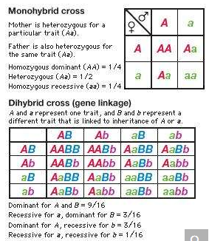

Punnett square diagrams are used to predict all the possible gene combinations that could result from the mating of parents with known genotypes for a particular trait. A monohybrid cross represents the inheritance pattern of a single trait, whereas a dihybrid cross represents the inheritance patterns of two traits that are linked.

When such a population reproduces itself to make a new generation, the lack of change is made apparent. It is intuitive that the allele frequencies p and q in the population are also measures of the frequencies of eggs and sperm used in creating a new generation (represented in the formula below). The new generation produced from the zygotes has exactly the same genotypic proportions as the first generation (the parents of the zygote).

Some specific allele frequencies, 0.7 for p and 0.3 for q, can be used to illustrate the calculation of the genotypic frequencies that constitute the Hardy-Weinberg equilibrium:

p × p = 0.7 × 0.7 = 0.49 of AA

2 × p × q = 2 × 0.7 × 0.3 = 0.42 of Aa

q × q = 0.3 × 0.3 = 0.09 of aa

When this population reproduces, there will be 0.49 + 0.21 = 0.7 of A gametes and 0.09 + 0.21 = 0.3 of a gametes, and, when these gametes combine, the population in the next generation will clearly have the same genotypic proportions as the previous one.

These simple calculations rely on several underlying assumptions. Perhaps the most crucial one is that there is random mating, or mating regardless of the genotype of the partner. In addition, the population must be large, and there can be no other pressures, such as selection, that can change allele frequencies. Despite these stringent requirements, many natural populations that have been studied are in Hardy-Weinberg equilibrium for the genes under investigation. The Hardy-Weinberg equilibrium constitutes an important benchmark for population genetic analysis.

If the Hardy-Weinberg principle of population genetics shows that there is no inherent tendency for evolutionary change, then how does change occur? This is considered in the following sections.

**Changes in gene frequencies**

**Selection**

One assumption behind the calculation of unchanging genotypic frequencies in Hardy-Weinberg equilibrium is that all genotypes have the same fitness. In genetics, fitness does not necessarily have to do with muscles; fitness is a measure of the ability to produce fertile offspring. In reality, the fitnesses of different genotypes are highly variable. The genotype with the greatest fitness is given the fitness value (w) of 1, and the lesser fitnesses are fractions of 1. For example, if snails of genotypes AA and Aa were to have an average of 100 offspring but those of genotype aa only 70, then the fitnesses of these three genotypes would be 1, 1, and 0.7, respectively. The proportional difference from the most fit is called the selection coefficient, s. Hence, s = 1 − w.

Alleles carried by less-fit individuals will be gradually lost from the population, and the relevant allele frequency will decline. This is the fundamental way in which natural selection operates in a population. Selection against dominant alleles is relatively efficient, because these are by definition expressed in the phenotype. Selection against recessive alleles is less efficient, because these alleles are sheltered in heterozygotes. Even though populations under selection technically are not in Hardy-Weinberg equilibrium, the proportions of the formula can be used as an approximation to show the relative proportions of homozygous recessives and heterozygotes. If a rare deleterious recessive allele is of frequency 1/50 in the population, then (1/50)2, or 1 out of 2,500, individuals will express the recessive phenotype and be a candidate for negative selection. Heterozygotes will be at a frequency of 2pq = 2 × 49/50 × 1/50, or about 1 in 25. In other words, the heterozygotes are 100 times more common than recessive homozygotes; hence, most of the recessive alleles in a population will escape selection.

Because of the sheltering effect of heterozygotes, selection against recessive phenotypes changes the frequency of the recessive allele slowly. Even if the most severe level of selection is imposed, giving the recessive phenotype a fitness of zero (no fertile offspring), the recessive allele frequency (expressed as a fraction of the form 1/x) will increase in denominator by 1 in every generation. Therefore, to halve an allele frequency from 1/50 to 1/100 would proceed slowly from 1/50 to 1/51, 1/52, 1/53, and so on and would take 50 generations to get to 1/100. For lower intensities of selection, the progress would be even slower.

A different type of natural selection occurs when the fitness of a heterozygote exceeds the fitness of both homozygotes. The maintenance in human populations of the severe hereditary disease sickle cell anemia is owing to this form of selection. The disease allele (HbS) produces a specific type of hemoglobin that causes distortion (sickling) of the red blood cells in which the hemoglobin is carried. (Normal hemoglobin is coded by another allele, HbA). Accordingly, the possible genotypes are HbAHbA, HbAHbS, and HbSHbS. The latter individuals are homozygous for the sickle cell allele and will develop severe anemia because the oxygen transporting property of their blood is compromised. While the condition is not lethal before birth, such individuals rarely survive long enough to reproduce. On these grounds it might be expected that the disease allele would be selected against, driving the allele frequency to very low levels. However, in tropical areas of the world, the allele and the disease are common. The explanation is that the HbAHbS heterozygote is fitter and capable of leaving more offspring than is the homozygous normal HbAHbA in an environment containing the falciparum form of malaria. This extra measure of protection is evidently provided by the sickle cell hemoglobin, which is detrimental to the malaria parasite. In malarial environments, therefore, populations that contain the sickle cell gene have advantages over populations free of this gene. The former populations are in less danger from malaria, although they “pay” for this advantage by sacrificing in every generation some individuals who die of anemia.

**Mutation**

Genetics has shown that mutation is the ultimate source of all hereditary variation. At the level of a single gene whose normal functional allele is A, it is known that mutation can change it to a nonfunctional recessive form, a. Such “forward mutation” is more frequent than “back mutation” (reversion), which converts a into A. Molecular analysis of specific examples of mutant recessive alleles has shown that they are generally a heterogeneous set of small structural changes in the DNA, located throughout the segment of DNA that constitutes that gene. Hence, in an example from medical genetics, the disease phenylketonuria is inherited as a recessive phenotype and is ascribed to a causative allele that generally can be called k. However, sequencing alleles of many independent cases of phenylketonuria has shown that this k allele is in fact a set of many different kinds of mutational changes, which can be in any of the protein-coding regions of that gene.

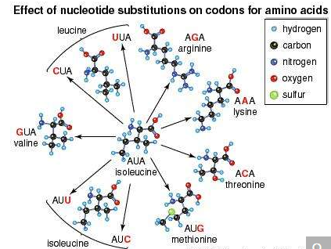

The effect of base substitutions, or point mutations, on the messenger-RNA codon AUA, which codes for the amino acid isoleucine. Substitutions (red letters) at the first, second, or third position in the codon can result in nine new codons corresponding to six different amino acids in addition to isoleucine itself. The chemical properties of some of these amino acids are quite different from those of isoleucine. Replacement of one amino acid in a protein by another can seriously affect the protein's biological function.

Recessive deleterious mutations are relatively rare, generally in the order of 1 per 105 or 106 mutant gametes per generation. Their constant occurrence over the generations, combined with the even greater rarity of back mutations, leads to a gradual accumulation in the population. This accumulation process is called mutational pressure.

Since mutational pressure to a deleterious recessive allele and selection pressure against the homozygous recessives are forces that act in opposite directions, another type of equilibrium is attained that effectively sets the value of q. Mathematically, q is determined by the following expression in which u is the net mutation rate of A to a, and s is the selection coefficient presented above:

q2 = (u/s), or q = Square root of√(u/s)

**Nonrandom mating**

Many species engage in alternatives to random mating as normal parts of their cycle of sexual reproduction. An important exception is sexual selection, in which an individual chooses a mate on the basis of some aspect of the mate’s phenotype. The selection can be based on some display feature such as bright feathers, or it may be a simple preference for a phenotype identical to the individual’s own (positive assortative mating).

Two other important exceptions are inbreeding (mating with relatives) and enforced outbreeding. Both can shift the equilibrium proportions expected under Hardy-Weinberg calculations. For example, inbreeding increases the proportions of homozygotes, and the most extreme form of inbreeding, self-fertilization, eventually eliminates all heterozygotes.

Inbreeding and outbreeding are evolutionary strategies adopted by plants and animals living under certain conditions. Outbreeding brings gametes of different genotypes together, and the resulting individual differs from the parents. Increased levels of variation provide more evolutionary flexibility. All the showy colors and shapes of flowers are to promote this kind of exchange. In contrast, inbreeding maintains uniform genotypes, a strategy successful in stable ecological habitats.

In humans, various degrees of inbreeding have been practiced in different cultures. In most cultures today, matings of first cousins are the maximal form of inbreeding condoned by society. Apart from ethical considerations, a negative outcome of inbreeding is that it increases the likelihood of homozygosity of deleterious recessive alleles originating from common ancestors, called homozygosity by descent. The inbreeding coefficient F is a measure of the likelihood of homozygosity by descent; for example, in first-cousin marriages, F = 1/16. A large proportion of recessive hereditary diseases can be traced to first-cousin marriages and other types of inbreeding.

**Random genetic drift**

In populations of finite size, the genetic structure of a new generation is not necessarily that of the previous one. The explanation lies in a sampling effect, based on the fact that a subsample from any large set is not always representative of the larger set. The gametes that form any generation can be thought of as a sample of the alleles from the parental one. By chance the sample might not be random; it could be skewed in either direction. For example, if p = 0.600 and q = 0.400, sampling “error” might result in the gametes having a p value of 0.601 and a q of 0.399. If by chance this skewed sampling occurs in the same direction from generation to generation, the allele frequency can change radically. This process is known as random genetic drift. As might be expected, the smaller the population, the greater chance of sampling error and hence significant levels of drift in any one generation. In extreme cases, drift over the generations can result in the complete loss of one allele; in these occurrences the other is said to be fixed.

Other cases of sampling error occur when new colonies of plants or animals are founded by small numbers of migrants (founder effect) and when there is radical reduction in population size because of a natural catastrophe (population bottleneck). One inevitable effect of these processes is a reduction in the amount of variation in the population after the size reduction. Two species that have gone through drastic bottlenecks with the associated reduction of genetic variation are cheetahs (Africa) and northern elephant seals (North America).

**Microevolution**

There is ample evidence that the processes described above are at work in natural populations. Together, these changes are called microevolution—in other words, small-scale evolution. Even within the relatively short period of time since Darwin, it has been possible to document such processes. Allelic variation has been found to be common in nature. It is detected as polymorphism, the presence of two or more distinct hereditary forms associated with a gene. Polymorphism can be morphological, such as blue and brown forms of a species of marine mussel, or molecular, detectable only at the DNA or protein level. Although much of this polymorphism is not understood, there are enough examples of selection of polymorphic forms to indicate that it is potentially adaptive. Selection has been observed favouring melanic (dark) forms of peppered moths in industrial areas and favouring resistance to toxic agents such as the insecticide DDT, the rat poison warfarin, and the virus that causes the disease myxomatosis in rabbits.

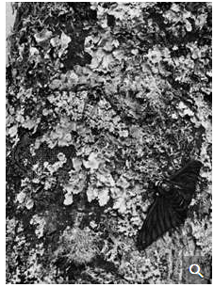

industrial melanism in the peppered moth

The light gray form of the peppered moth (Biston betularia) is inconspicuous on the lichen-covered tree trunk. In contrast, the dark (melanic) morph stands out, leaving it vulnerable to predation by birds. The gradual darkening of the wings of the melanic peppered moth, the result of living in woodlands darkened by industrial pollution, is an example of industrial melanism.

From the experiments of Dr. H.B.D. Kettlewell, University of Oxford; photographs by John S. Haywood

More-complex genetic changes have been documented, leading to special locally adapted “ecotypes.” Anoles (a type of lizard) on certain Caribbean islands show convincing examples of adaptations to specific habitats, such as tree trunks, tree branches, or grass. Introductions of lizards onto uncolonized islands result in demonstrable microevolutionary adaptations to the various vacant niches. On the Galapagos Islands, studies over several decades have documented adaptive changes in the beaks of finches. In some studies, documented changes have led to incipient new species. An example is the apple maggot, the larva of a fly in North America that has evolved from a similar fly living on hawthorns—all in the period since the introduction of apples. The formation of new species was a key component of Darwin’s original theory. Now it appears that the accumulation of enough small-scale genetic changes can lead to the inability to mate with members of an ancestral population; such reproductive isolation is the key step in species formation.

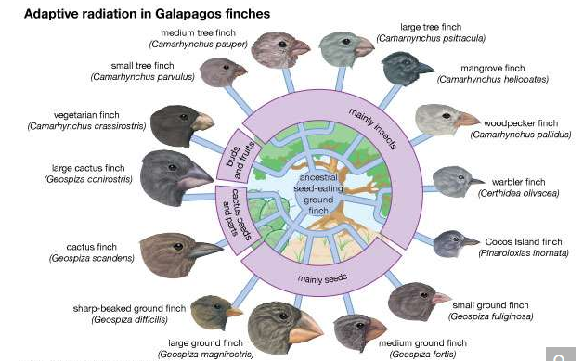

Fourteen species of Galapagos finches that evolved from a common ancestor. The different shapes of their bills, suited to different diets and habitats, show the process of adaptive radiation.

It is reasonable to assume that the continuation of microevolutionary genetic changes over very long periods of time can give rise to new major taxonomic groups, the process of macroevolution. There are few data that bear directly on the processes of macroevolution, but gene analysis does provide a way for charting macroevolutionary relationships indirectly.

**DNA phylogeny**

The ability to isolate and sequence specific genes and genomes has been of great significance in deducing trees of evolutionary relatedness. An important discovery that enables this sort of analysis is the considerable evolutionary conservation between organisms at the genetic level. This means that different organisms have a large proportion of their genes in common, particularly those that code for proteins at the central core of the chemical machinery of the cell. For example, most organisms have a gene coding for the energy-producing protein cytochrome C, and furthermore, this gene has a very similar nucleotide sequence in all organisms (that is, the sequence is conserved). However, the sequences of cytochrome C in different organisms do show differences, and the key to phylogeny is that the differences are proportionately fewer between organisms that are closely related. The interpretation of this observation is that organisms that share a common ancestor also share common DNA sequences derived from that ancestor. When one ancestral species splits into two, differences accumulate as a result of mutations, a process called divergence. The greater the amount of divergence, the longer must have been the time since the split occurred. To carry out this sort of analysis, the DNA sequence data are fed into a computer. The computer positions similar species together on short adjacent branches showing a relatively recent split and dissimilar species on long branches from an ancient split. In this way a molecular phylogenetic tree of any number of organisms can be drawn.

Figure : Phylogeny based on differences in the protein sequence of cytochrome c in organisms ranging from Neurospora mold to humans.

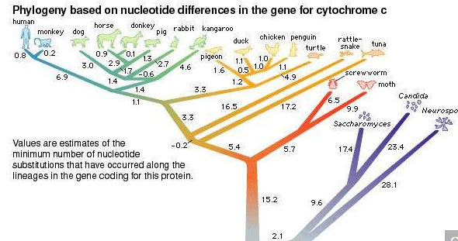

DNA difference in some cases can be correlated with absolute dates of divergence as deduced from the fossil record. Then it is possible to calculate divergence as a rate. It has been found that divergence is relatively constant in rate, giving rise to the idea that there is a type of “molecular clock” ticking in the course of evolution. Some ticks of this clock (in the form of mutations) are significant in terms of adaptive changes to the gene, but many are undoubtedly neutral, with no significant effect on fitness.

One of the interesting discoveries to emerge from molecular phylogeny is that gene duplication has been common during evolution. If an extra copy of a gene can be made, initially by some cellular accident, then the “spare” copy is free to mutate and evolve into a separate function.

Molecular phylogeny of some genes has also pointed to unexpected cases of, say, a plant gene nested within a tree of animal genes of that type or a bacterial gene nested within a plant phylogenetic tree. The explanation for such anomalies is that there has been horizontal transmission from one group to another. In other words, on rare occasions a gene can hop laterally from one species to another. Although the mechanisms for horizontal transmission are presently not known, one possibility is that bacteria or viruses act as natural vectors for transferring genes.

**Synteny**

Genomic sequencing and mapping have enabled comparison of the general structures of genomes of many different species. The general finding is that organisms of relatively recent divergence show similar blocks of genes in the same relative positions in the genome. This situation is called synteny, translated roughly as possessing common chromosome sequences. For example, many of the genes of humans are syntenic with those of other mammals—not only apes but also cows, mice, and so on. Study of synteny can show how the genome is cut and pasted in the course of evolution.

**Polyploidy**

Genomic analysis also has shown that one of the important mechanisms of evolution is multiplication of chromosome sets, resulting in polyploidy (“many genomes”). In plants and animals, spontaneous doubling of chromosomes can occur. In some plants, the chromosomes of two related species unite via cross-pollination to form a fusion product. This product is sterile because each chromosome needs a pairing partner in order for the plant to be fertile. However, the chromosomes of the fusion product can accidentally double, resulting in a new, fertile species. Wheat is an example of a plant that evolved by this means through a union between wild grasses, but a large proportion of plants went through similar ancestral polyploidization.

**Human evolution**

Many of the techniques of evolutionary genetics can be applied to the evolution of humans. Charles Darwin created a large controversy in Victorian England by suggesting in his book The Descent of Man that humans and apes share a common ancestor. Darwin’s assertion was based on the many shared anatomical features of apes and humans. DNA analysis has supported this hypothesis. At the DNA sequence level, the genomes of humans and chimpanzees are 99 percent identical. Furthermore, when phylogenetic trees are constructed using individual genes, humans and apes cluster together in short terminal branches of the trees, suggesting very recent divergence. Synteny too is impressive, with relatively minor chromosomal rearrangements.

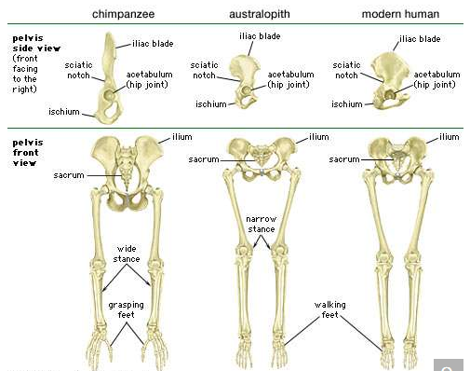

Comparison of the pelvis and lower limbs of a chimpanzee, an australopith, and a modern human.

Fossils have been found of various extinct forms considered to be intermediates between apes and humans. Notable is the African genus Australopithecus, generally believed to be one of the earliest hominins and an intermediate on the path of human evolution. The first toolmaker was Homo habilis, followed by Homo erectus and finally Homo sapiens (modern humans). H. habilis fossils have been found only in Africa, whereas fossils of H. erectus and H. sapiens are found throughout the Old World. Phylogenetic trees based on DNA sequencing of all peoples have shown that Africans represent the root of the trees. This is interpreted as evidence that H. sapiens evolved in Africa, spread throughout the globe, and outcompeted H. erectus wherever the two cohabited.

Variations of DNA, either unique alleles of individual genes or larger-sized blocks of variable structure, have been used as markers to trace human migrations across the globe. Hence, it has been possible to trace the movement of H. sapiens out of Africa and into Europe and Asia and, more recently, to the American continents. Also, genetic markers are useful in plotting human migrations that occurred in historical time. For example, the invasion of Europe by various Asian conquerors can be followed using blood-type alleles.

As humans colonized and settled permanently in various parts of the world, they differentiated themselves into distinct groups called races. Undoubtedly, many of the features that distinguish races, such as skin colour or body shape, were adaptive in the local settings, although such adaptiveness is difficult to demonstrate. Nevertheless, genomic analysis has revealed that the concept of race has little meaning at the genetic level. The differences between races are superficial, based on the alleles of a relatively small number of genes that affect external features. Furthermore, while races differ in allele frequencies, these same alleles are found in most races. In other words, at the genetic level there are no significant discontinuities between races. It is paradoxical that race, which has been so important to people throughout the course of human history, is trivial at the genetic level—an important insight to emerge from genetic analysis.

**Actin filaments**

Actin is a globular protein that polymerizes (joins together many small molecules) to form long filaments. Because each actin subunit faces in the same direction, the actin filament is polar, with different ends, termed “barbed” and “pointed.” An abundant protein in nearly all eukaryotic cells, actin has been extensively studied in muscle cells. In muscle cells, the actin filaments are organized into regular arrays that are complementary with a set of thicker filaments formed from a second protein called myosin. These two proteins create the force responsible for muscle contraction. When the signal to contract is sent along a nerve to the muscle, the actin and myosin are activated. Myosin works as a motor, hydrolyzing adenosine triphosphate (ATP) to release energy in such a way that a myosin filament moves along an actin filament, causing the two filaments to slide past each other. The thin actin filaments and the thick myosin filaments are organized in a structure called the sarcomere, which shortens as the filaments slide over one another. Skeletal muscles are composed of bundles of many long muscle cells; when the sarcomeres contract, each of these giant muscle cells shortens, and the overall effect is the contraction of the entire muscle. Although the stimulation pathways differ, heart muscle and smooth muscle (found in many internal organs and blood vessels) contract by a similar sliding filament mechanism.

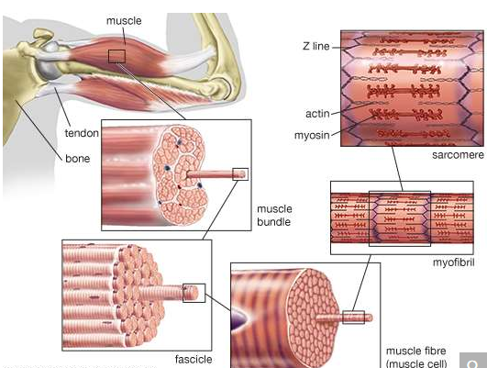

The structure of striated muscleStriated muscle tissue, such as the tissue of the human biceps muscle, consists of long, fine fibres, each of which is in effect a bundle of finer myofibrils. Within each myofibril are filaments of the proteins myosin and actin; these filaments slide past one another as the muscle contracts and expands. On each myofibril, regularly occurring dark bands, called Z lines, can be seen where actin and myosin filaments overlap. The region between two Z lines is called a sarcomere; sarcomeres can be considered the primary structural and functional unit of muscle tissue.

Actin is also present in non-muscle cells, where it forms a meshwork of filaments responsible for many types of cellular movement. The meshwork consists of actin filaments that are attached to the cell membrane and to each other. The length of the filaments and the architecture of their attachments determine the shape and consistency of a cell. A large number of accessory proteins bind to actin, controlling the number, length, position, and attachments of the actin filaments. Different cells and tissues contain different accessory proteins, which accounts for the different shapes and movements of different cells. For example, in some cells, actin filaments are bundled by accessory proteins, and the bundle is attached to the cell membrane to form microvilli, stable protrusions that resemble tiny bristles. Microvilli on the surface of epithelial cells such as those lining the intestine increase the cell’s surface area and thus facilitate the absorption of ingested food and water molecules. Other types of microvilli are involved in the detection of sound in the ear, where their movement, caused by sound waves, sends an electrical signal to the brain.

Many actin filaments in non-muscle cells have only a transient existence, polymerizing and depolymerizing in controlled ways that create movement. For example, many cells continually send out and retract tiny “filopodia,” long needlelike projections of the cell membrane that are thought to enable cells to probe their environment and decide which direction to go. Like microvilli, filopodia are formed when actin filaments push out the membrane, but, because these actin filaments are less stable, filopodia have only a brief existence. Another actin structure only transiently associated with the cell membrane is the contractile ring, which is composed of actin filaments running around the circumference of the cell during cell division. As its name implies, this ring pulls in the cell membrane by a myosin-dependent process, thereby pinching the cell in half.

**Microtubules**

Microtubules are long filaments formed from 13 to 15 protofilament strands of a globular subunit called tubulin, with the strands arranged in the form of a hollow cylinder. Like actin filaments, microtubules are polar, having “plus” and “minus” ends. Most microtubule plus ends are constantly growing and shrinking, by respectively adding and losing subunits at their ends. Stable microtubules are found in cilia and flagella. Cilia are hairlike structures found on the surface of certain types of epithelial cells, where they beat in unison to move fluid and particles over the cell surface. Cilia are closely related in structure to flagella. Flagella such as those found on sperm cells produce a helical wavelike motion that enables a cell to propel itself rapidly through fluids. In cilia and flagella a set of microtubules is connected in a regular array by numerous accessory proteins that act as links and spokes in the assembly. Movement of the cilia or flagella occurs when adjacent microtubules slide past one another, bending the structures. This motion is caused by the motor protein dynein, which uses the energy of ATP hydrolysis to move along the microtubules, in a manner resembling the movement of myosin along actin filaments.

In most cells, microtubules grow outward, from the cell centre to the cell membrane, from a special region of the cytoplasm near the nuclear envelope called the centrosome. The minus ends of these microtubules are embedded in the centrosome, while the plus ends terminate near the cell membrane. The plus ends grow and shrink rapidly, a process known as dynamic instability. At the start of cell division, the centrosome replicates and divides in two. The two centrosomes separate and move to opposite sides of the nuclear envelope, where each nucleates a starlike array of microtubules, forming the mitotic spindle. The mitotic spindle partitions the duplicated chromosomes into the two daughter cells during mitosis.

Microtubules often serve as tracks for the transport of membrane vesicles in the cell, carried by the motor proteins kinesin and dynein. Kinesins generally move toward the plus end of the microtubule, and dyneins move toward the minus end. Microtubule-based vesicle transport occurs in nearly all cells, but it is especially prominent in the long thin processes of neurons, carrying essential components to and from the synapses at the ends of the processes.

**Intermediate filaments**

Intermediate filaments are so named because they are thicker than actin filaments and thinner than microtubules or muscle myosin filaments. The subunits of intermediate filaments are elongated, not globular, and are associated in an antipolar manner. As a result, the overall filament has no polarity, and therefore no motor proteins move along intermediate filaments. Intermediate filaments are found only in complex multicellular organisms. They are encoded by a large number of different genes and can be grouped into families based on their amino acid sequences. Cells in different tissues of the body express one or another of these genes at different times. One cell can even change which type of intermediate filament protein is expressed over its lifetime. Most likely, the different forms of intermediate filaments have subtle but critical differences in their functional characteristics, helping to define the function of the cell. In general, intermediate filaments serve as structural elements, helping cells maintain their shape and integrity. For example, keratin filaments, the intermediate filaments of epithelial cells, which line surfaces of the body, give strength to the cell sheet that covers the surface. Mutations in keratin genes can result in blisters when the epithelial cell sheet is weak and prone to rupture. Keratin mutations can also cause deformations in the hair, nails, and corneas. Another example of a family of intermediate filaments is the lamin family, which comprises the nuclear lamina, a fibrous shell that underlies and supports the nuclear membrane.

**The Cell Matrix And Cell-To-Cell Communication**

The development of single cells into multicellular organisms involves a number of adaptations. The cells become specialized, acquiring distinct functions that contribute to the survival of the organism. The behaviour of individual cells is also integrated with that of similar cells, so that they act together in a regulated fashion. To achieve this integration, cells assemble into specialized tissues, each tissue being composed of cells and the spaces outside of the cells.

The surface of cells is important in coordinating their activities within tissues. Embedded in the plasma membrane of each cell are a number of proteins that interact with the surface or secretions of other cells. These proteins enable cells to “recognize” and adhere to the extracellular matrix and one another and to form populations distinct from surrounding cells. These interactions are key to the organizational behaviour of cell populations and contribute to the formation of embryonic tissues and the function of normal tissue in the adult organism.

**The extracellular matrix**

A substantial part of tissues is the space outside of the cells, called the extracellular space. This is filled with a composite material, known as the extracellular matrix, composed of a gel in which a number of fibrous proteins are suspended. The gel consists of large polysaccharide (complex sugar) molecules in a water solution of inorganic salts, nutrients, and waste products known as the interstitial fluid. The major types of protein in the matrix are structural proteins and adhesive proteins.

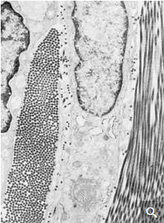

Electron micrograph of a small area of dense fibrous connective tissue, illustrating the intimate association of cells and fibres. In the centre is a portion of a fibrocyte, and on either side are two collagen fibres. The collagen fibre on the left is cut transversely, showing round cross sections of the unit fibrils. The collagen fibre on the right has been cut nearly parallel to its long axis and shows extensive segments of the cross-striated fibrils.

There are two general types of tissues distinct not only in their cellular organization but also in the composition of their extracellular matrix. The first type, mesenchymal tissue, is made up of clusters of cells grouped together but not closely adherent to one another. They synthesize a highly hydrated gel, rich in salts, fluid, and fibres, known as the interstitial matrix. Connective tissue is a mesenchyme that fastens together other more highly organized tissues. The solidity of various connective tissues varies according to the consistency of their extracellular matrix, which in turn depends on the water content of the gels, the amount and type of polysaccharides and structural proteins, and the presence of other salts. For example, bone is rich in calcium phosphate, giving that tissue its rigidity; tendons are mostly fibrous structural proteins, yielding a ropelike consistency; and joint spaces are filled with a lubricating fluid of mostly polysaccharide and interstitial fluid.

Epithelial tissues, the second type, are sheets of cells adhering at their side, or lateral, surfaces. They synthesize and deposit at their bottom, or basal, surfaces an organized complex of matrix materials known as the basal lamina or basement membrane. This thin layer serves as a boundary with connective tissue and as a substrate to which epithelial cells are attached.

**Matrix polysaccharides**

The polysaccharides, or glycans, of the extracellular matrix are responsible for its gel-like quality and for organizing its components. These large acidic molecules exist alone (as glycosaminoglycans) or in combination with small proteins (as proteoglycans). They bind an extraordinarily large amount of water, thus forming massively swollen gels that fill the spaces between cells. Bound to proteins, they also organize other molecules in the extracellular matrix. The firmness and resiliency of cartilage, as at the surface of joints, is due to highly organized proteoglycans that bind water tightly.

**Matrix proteins**

Matrix proteins are large molecules tightly bound to form extensive networks of insoluble fibres. These fibres may even exceed the size of the cells themselves. The proteins are of two general types, structural and adhesive.

The structural proteins, collagen and elastin, are the dominant matrix proteins. At least 10 different types of collagen are present in various tissues. The most common, type I collagen, is the most abundant protein in vertebrate animals, accounting for nearly 25 percent of the total protein in the body. The various collagen types share structural features, all being composed of three intertwined polypeptide chains. In some collagens the chains are linked together by covalent bonds, yielding a ropelike structure of great tensile strength. Indeed, the toughness of leather, chemically treated animal skin, is due to its content of collagen. Elastin is also a cross-linked protein, but, instead of forming rigid coils, it imparts elasticity to tissues. Only one type of elastin is known; it varies in elasticity according to variations in its cross-linking.

The adhesive proteins of the extracellular matrix bind matrix molecules to one another and to cell surfaces. These proteins are modular in that they contain several functional domains packaged together in a single molecule. Each domain binds to a specific matrix component or to a specific site on a cell. The major adhesive protein of the interstitial matrix is called fibronectin; that of the basal lamina is known as laminin.

**Cell-matrix interactions**

Molecules intimately associated with the cell membrane link cells to the extracellular matrix. These molecules, called matrix receptors, bind selectively to specific matrix components and interact, directly or indirectly, with actin protein fibres that form the cytoskeleton inside the cell. This association of actin fibres with matrix components via receptors on the cell membrane can influence the organization of membrane molecules as well as matrix components and can modify the shape and function of the cytoskeleton. Changes in the cytoskeleton can lead to changes in cell shape, movement, metabolism, and development.

**Intercellular recognition and cell adhesion**

The ability of cells to recognize and adhere to one another plays an important role in cell survival and reproduction. For example, when starved, several types of single-cell organisms band together to develop the specialized cells needed for reproduction. In this process, certain cells at the centre of the developing aggregate secrete chemicals that cause the other cells to adhere tightly into a group. In the case of slime mold amoebas, starvation causes the secretion of a compound, cyclic adenosine monophosphate (cyclic AMP, or CAMP), that induces the cells to stick together end to end. With further aggregation, the cells produce another cell-surface glycoprotein with which they stick to one another over their entire surfaces. The cellular aggregates then produce an extracellular matrix, which holds the cells together in a specific structural form.

**Tissue and species recognition**

Some multicellular animals or tissues can be dissociated into suspensions of single cells that show the same cellular recognition and adhesion as do aggregates of single-cell organisms. The marine sponge, for example, can be sieved through a mesh, yielding single cells and cells in clumps. When this cell suspension is rotated in culture, the cells reaggregate and in time reform a normal sponge. This reassociation shows selective cell recognition; that is, only cells of the same species reassociate. The ability of the cells to distinguish cells of their own species from those of others is mediated by proteoglycan molecules in the extracellular matrix. The proteoglycan binds to specific cell-surface receptor sites that are unique to a single species of sponge.

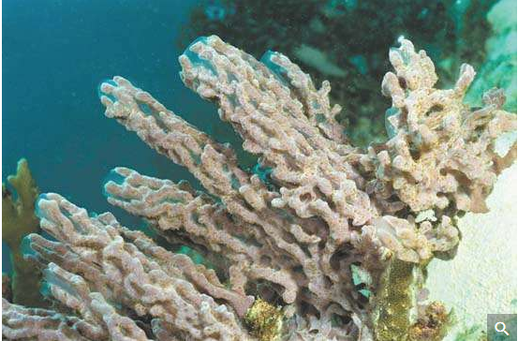

Marine sponges are multicellular animals that can regenerate from single cells. The cells of a sponge rely on the processes of intercellular recognition and cellular adhesion to form aggregates of cells of the same species that eventually develop into an adult sponge.

Cells from tissues of vertebrate animals can, like sponge cells, be dissociated and allowed to reaggregate. For example, when vertebrate embryonic cells from two different tissues are dissociated and then rotated together in culture, the cells form a multicellular aggregate within which they sort according to the type of tissue, a sorting that occurs regardless of whether the cells are from the same or different species. The specificity is due to a set of cell-surface glycoproteins called cell adhesion molecules (CAM). A portion of the CAM that extends from the surface of a cell adheres to identical molecules on the surface of adjacent cells. These CAM appear early in embryonic life, and their amounts in tissues change as the organs develop. The CAM, however, are not responsible for the stable adhesion of one cell to another; this more permanent adhesion is carried out by cell junctions.

**Cell junctions**

There are three functional categories of cell junction: adhering junctions, often called desmosomes; tight, or occluding, junctions; and gap, or permeable, junctions. Adhering junctions hold cells together mechanically and are associated with intracellular fibres of the cytoskeleton. Tight junctions also hold cells together, but they form a nearly leakproof intercellular seal by fusion of adjacent cell membranes. Both adhering junctions and tight junctions are present primarily in epithelial cells. Many cell types also possess gap junctions, which allow small molecules to pass from one cell to the next through a channel.

**Adhering junctions**

Cells subject to abrasion or other mechanical stress, such as those of the surface epithelia of the skin, have junctions that adhere cells to one another and to the extracellular matrix. These adhering junctions are called desmosomes when occurring between cells and hemidesmosomes (half-desmosomes) when linked to the matrix. Adhering junctions distribute mechanical shear force throughout the tissue and to the underlying matrix by virtue of their association with intermediate filaments crossing the interior of the cell. The linkage of these filaments, also called keratin filaments, to the desmosomes and, through these junctions, to adjacent cells provides a nearly continuous fibrous network throughout an epithelial sheet. Adhering junctions are also seen in other types of cells—for example, in the muscles of the heart and uterus—allowing these cells to remain anchored together despite the contractions of the muscles.

**Tight junctions**

Sheets of cells separate fluids within the organs from fluids outside, as in the epithelial layer lining the intestine. This separation requires leakproof junctions between cells. Tight junctions form leakproof seals by fusing the plasma membranes of adjacent cells, creating a continuous barrier through which molecules cannot pass. The membranes are fused by tight associations of two types of specialized integral membrane proteins, in turn repelling large water-soluble molecules. In invertebrates this function is provided by septate junctions, in which the proteins of the membrane rather than the lipids form the seal.

**Gap junctions**

These junctions allow communication between adjacent cells via the passage of small molecules directly from the cytoplasm of one cell to that of another. Molecules that can pass between cells coupled by gap junctions include inorganic salts, sugars, amino acids, nucleotides, and vitamins but not large molecules such as proteins or nucleic acids.

Gap junctions are crucial to the integration of certain cellular activities. For example, heart muscle cells generate electrical current by the movement of inorganic salts. If the cells are coupled, they will share this electrical current, allowing the synchronous contraction of all the cells in the tissue. This coupling function requires the regulation of molecular traffic through the gaps. The junctions are not open pores but dynamic channels, which change their permeability with changes in cellular activity. They consist of proteins completely crossing the cell membrane as six-sided columns with central pores. Under certain conditions the proteins are thought to change shape, causing the pores to become smaller or larger and thus changing the permeability of the junction.

Gap junctions are also found in tissues that are not electrically active. In these tissues, the junctions allow nutrients and waste products to travel throughout the tissue. Cells in such tissues are said to be metabolically coupled. During the formation of embryos, gap junctions are crucial to establishing differences between separate groups of cells, the coupled cells undergoing development together to become a specialized tissue.

**Cell-to-cell communication via chemical signaling**

In addition to cell-matrix and cell-cell interactions, cell behaviour in multicellular organisms is coordinated by the passage of chemical or electrical signals between cells. The most common form of chemical signaling is via molecules secreted from the cells and moving through the extracellular space. Signaling molecules may also remain on cell surfaces, influencing other cells only after the cells make physical contact. Finally, as noted above, gap junctions allow small molecules to move between the cytoplasms of adjacent cells.

**Types of chemical signaling**

Chemical signals secreted by cells can act over varying distances. In the autocrine signaling process, molecules act on the same cells that produce them. In paracrine signaling, they act on nearby cells. Autocrine signals include extracellular matrix molecules and various factors that stimulate cell growth. An example of paracrine signals is the chemical transmitted from nerve to muscle that causes the muscle to contract. In this instance, the muscle cells have regions specialized to receive chemical signals from an adjacent nerve cell. In both autocrine and paracrine signaling, the chemical signal works in the immediate vicinity of the cell that produces it and is present at high concentrations. A chemical signal picked up by the bloodstream and taken to distant sites is called an endocrine signal. Most hormones produced in vertebrates are endocrine signals, such as the hormones produced in the pituitary gland at the base of the brain and carried by the bloodstream to act at low concentrations on the thyroid or adrenal glands.

The concentration at which a chemical signal acts has significance for its target cell. Chemical signals that act at high concentration act locally and rapidly. On the other hand, chemical signals that act at low concentrations act at distances and are generally slow.

**Signal receptors**

The ability of a cell to respond to an extracellular signal depends on the presence of specific proteins called receptors, which are located on the cell surface or in the cytoplasm. Receptors bind chemical signals that ultimately trigger a mechanism to modify the behaviour of the target cell. Cells may contain an array of specific receptors that allow them to respond to a variety of chemical signals.

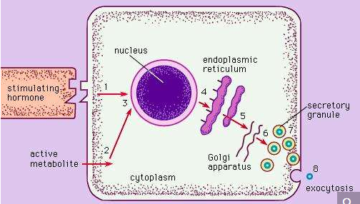

Hormones and active metabolites bind to different types of receptors. Water-soluble molecules (i.e., insulin) cannot pass through the lipid membrane of a cell and thus rely on cell surface receptors to transmit messages to the interior of the cell. In contrast, lipid-soluble molecules (i.e., certain active metabolites) are able to diffuse through the lipid membrane to communicate messages directly to the nucleus.

Hormones and active metabolites bind to different types of receptors. Water-soluble molecules (i.e., insulin) cannot pass through the lipid membrane of a cell and thus rely on cell surface receptors to transmit messages to the interior of the cell. In contrast, lipid-soluble molecules (i.e., certain active metabolites) are able to diffuse through the lipid membrane to communicate messages directly to the nucleus.

Signal molecules are either soluble or insoluble. Water-soluble molecules, such as the polypeptide hormone insulin, bind to receptors at cell surfaces. On the other hand, lipid-soluble molecules, such as the steroid hormones produced by the ovary or testis, pass through the lipid bilayer of the cell membrane to reach receptors within the cytoplasm. Extracellular matrix molecules are chemical signals, but, because of their size and insolubility, they act only on cell surface receptors and are neither taken up by the cells nor rapidly destroyed.

**Cellular response**

The binding of chemical signals to their corresponding receptors induces events within the cell that ultimately change its behaviour. The nature of these intracellular events differs according to the type of receptor. Also, the same chemical signal can trigger different responses in different types of cell.

Cell surface receptors work in several ways when they are occupied. Some receptors enter the cell still bound to the chemical signal. Others activate membrane enzymes, which produce certain intracellular chemical mediators. Still other receptors open membrane channels, allowing a flow of ions that causes either a change in the electrical properties of the membrane or a change in the ion concentration in the cytoplasm. This regulation of enzymes or membrane channels produces changes in the concentration of intracellular signaling molecules, which are often called second messengers (the first messenger being the extracellular chemical signal bound to the receptor).

Two common intracellular signaling molecules are cyclic AMP and the calcium ion. Cyclic AMP is a derivative of adenosine triphosphate, the ubiquitous energy-carrying molecule of the cell. The intracellular concentrations of both cyclic AMP and calcium ions are normally very low. The binding of an extracellular chemical signal to a cell surface receptor stimulates an enzyme complex in the membrane to produce cyclic AMP. This second messenger then diffuses into the cytoplasm and acts on intracellular enzymes called kinases that modify the behaviour of the cell, culminating in the activation of target genes that increase the synthesis of certain proteins. The action of cyclic AMP is brief because it is rapidly degraded by specific enzymes.

Occupancy of other surface receptors causes a transient opening of membrane channels. This can allow calcium ions to enter the cytoplasm from the extracellular space, where their concentration is higher. The action of calcium ions is also brief because they are rapidly pumped out of the cell or bound to intracellular molecules, lowering the cytoplasmic concentration to the state existing before stimulation.

Some extracellular chemical signals enter the cell intact, still bound to the receptor, without generating a second messenger. In this mechanism, receptor occupancy causes individual receptors within the cell membrane to aggregate spontaneously. That portion of the membrane containing the aggregated receptors is then taken into the cell, where it fuses with various membrane-bounded organelles in the cytoplasm. In some instances the chemical signal is released within the organelles, and in almost all instances the ingested membrane is rapidly returned to the cell membrane along with the surface receptors.

**The plant cell wall**

The plant cell wall is a specialized form of extracellular matrix that surrounds every cell of a plant and is responsible for many of the characteristics distinguishing plant from animal cells. Although often perceived as an inactive product serving mainly mechanical and structural purposes, the cell wall actually has a multitude of functions upon which plant life depends. Such functions include: (1) providing the protoplast, or living cell, with mechanical protection and a chemically buffered environment, (2) providing a porous medium for the circulation and distribution of water, minerals, and other small nutrient molecules, (3) providing rigid building blocks from which stable structures of higher order, such as leaves and stems, can be produced, and (4) providing a storage site of regulatory molecules that sense the presence of pathogenic microbes and control the development of tissues.

**Mechanical properties of wall layers**

All cell walls contain two layers, the middle lamella and the primary cell wall, and many cells produce an additional layer, called the secondary wall. The middle lamella serves as a cementing layer between the primary walls of adjacent cells. The primary wall is the cellulose-containing layer laid down by cells that are dividing and growing. To allow for cell wall expansion during growth, primary walls are thinner and less rigid than those of cells that have stopped growing. A fully grown plant cell may retain its primary cell wall (sometimes thickening it), or it may deposit an additional, rigidifying layer of different composition; this is the secondary wall. Secondary cell walls are responsible for most of the plant’s mechanical support as well as the mechanical properties prized in wood. In contrast to the permanent stiffness and load-bearing capacity of thick secondary walls, the thin primary walls are capable of serving a structural, supportive role only when the vacuoles within the cell are filled with water to the point that they exert a turgor pressure against the cell wall. Turgor-induced stiffening of primary walls is analogous to the stiffening of the sides of a pneumatic tire by air pressure. The wilting of flowers and leaves is caused by a loss of turgor pressure, which results in turn from the loss of water from the plant cells.

**Components of the cell wall**

Although primary and secondary wall layers differ in detailed chemical composition and structural organization, their basic architecture is the same, consisting of cellulose fibres of great tensile strength embedded in a water-saturated matrix of polysaccharides and structural glycoproteins.

**Cellulose**

Cellulose consists of several thousand glucose molecules linked end to end. The chemical links between the individual glucose subunits give each cellulose molecule a flat ribbonlike structure that allows adjacent molecules to band laterally together into microfibrils with lengths ranging from two to seven micrometres. Cellulose fibrils are synthesized by enzymes floating in the cell membrane and are arranged in a rosette configuration. Each rosette appears capable of “spinning” a microfibril into the cell wall. During this process, as new glucose subunits are added to the growing end of the fibril, the rosette is pushed around the cell on the surface of the cell membrane, and its cellulose fibril becomes wrapped around the protoplast. Thus, each plant cell can be viewed as making its own cellulose fibril cocoon.

**Matrix polysaccharides**

The two major classes of cell wall matrix polysaccharides are the hemicelluloses and the pectic polysaccharides, or pectins. Both are synthesized in the Golgi apparatus, brought to the cell surface in small vesicles, and secreted into the cell wall.

Hemicelluloses consist of glucose molecules arranged end to end as in cellulose, with short side chains of xylose and other uncharged sugars attached to one side of the ribbon. The other side of the ribbon binds tightly to the surface of cellulose fibrils, thereby coating the microfibrils with hemicellulose and preventing them from adhering together in an uncontrolled manner. Hemicellulose molecules have been shown to regulate the rate at which primary cell walls expand during growth.

The heterogeneous, branched, and highly hydrated pectic polysaccharides differ from hemicelluloses in important respects. Most notably, they are negatively charged because of galacturonic acid residues, which, together with rhamnose sugar molecules, form the linear backbone of all pectic polysaccharides. The backbone contains stretches of pure galacturonic acid residues interrupted by segments in which galacturonic acid and rhamnose residues alternate; attached to these latter segments are complex, branched sugar side chains. Because of their negative charge, pectic polysaccharides bind tightly to positively charged ions, or cations. In cell walls, calcium ions cross-link the stretches of pure galacturonic acid residues tightly, while leaving the rhamnose-containing segments in a more open, porous configuration. This cross-linking creates the semirigid gel properties characteristic of the cell wall matrix—a process exploited in the preparation of jellied preserves.

**Proteins**

Although plant cell walls contain only small amounts of protein, they serve a number of important functions. The most prominent group are the hydroxyproline-rich glycoproteins, shaped like rods with connector sites, of which extensin is a prominent example. Extensin contains 45 percent hydroxyproline and 14 percent serine residues distributed along its length. Every hydroxyproline residue carries a short side chain of arabinose sugars, and most serine residues carry a galactose sugar; this gives rise to long molecules, resembling bottle brushes, that are secreted into the cell wall toward the end of primary-wall formation and become covalently cross-linked into a mesh at the time that cell growth stops. Plant cells may control their ultimate size by regulating the time at which this cross-linking of extensin molecules occurs.

In addition to the structural proteins, cell walls contain a variety of enzymes. Most notable are those that cross-link extensin, lignin, cutin, and suberin molecules into networks. Other enzymes help protect plants against fungal pathogens by breaking fragments off of the cell walls of the fungi. The fragments in turn induce defense responses in underlying cells. The softening of ripe fruit and dropping of leaves in the autumn are brought about by cell wall-degrading enzymes.

**Plastics**

Cell wall plastics such as lignin, cutin, and suberin all contain a variety of organic compounds cross-linked into tight three-dimensional networks that strengthen cell walls and make them more resistant to fungal and bacterial attack. Lignin is the general name for a diverse group of polymers of aromatic alcohols. Deposited mostly in secondary cell walls and providing the rigidity of terrestrial vascular plants, it accounts for up to 30 percent of a plant’s dry weight. The diversity of cross-links between the polymers—and the resulting tightness—makes lignin a formidable barrier to the penetration of most microbes.

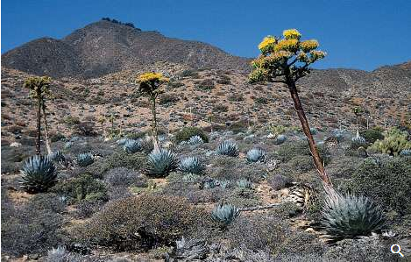

Agave shawii (top) and Echeveria (bottom), two types of xerophytes (plants adapted to arid habitats). They develop highly cutinized fleshy leaves and stems for water storage with which they modulate the effects of strong sunlight, low humidity, and scant water.

Cutin and suberin are complex biopolyesters composed of fatty acids and aromatic compounds. Cutin is the major component of the cuticle, the waxy, water-repelling surface layer of cell walls exposed to the environment aboveground. By reducing the wetability of leaves and stems—and thereby affecting the ability of fungal spores to germinate—it plays an important part in the defense strategy of plants. Suberin serves with waxes as a surface barrier of underground parts. Its synthesis is also stimulated in cells close to wounds, thereby sealing off the wound surfaces and protecting underlying cells from dehydration.

**Intercellular communication**

**Plasmodesmata**

Similar to the gap junction of animal cells is the plasmodesma, a channel passing through the cell wall and allowing direct molecular communication between adjacent plant cells. Plasmodesmata are lined with cell membrane, in effect uniting all connected cells with one continuous cell membrane. Running down the middle of each channel is a thin membranous tube that connects the endoplasmic reticula (ER) of the two cells. This structure is a remnant of the ER of the original parent cell, which, as the parent cell divided, was caught in the developing cell plate.

Although the precise mechanisms are not fully understood, the plasmodesma is thought to regulate the passage of small molecules such as salts, sugars, and amino acids by constricting or dilating the openings at each end of the channel.

**Oligosaccharides with regulatory functions**

The discovery of cell wall fragments with regulatory functions opened a new era in plant research. For years scientists had been puzzled by the chemical complexity of cell wall polysaccharides, which far exceeds the structural requirements of plant cell walls. The answer came when it was found that specific fragments of cell wall polysaccharides, called oligosaccharins, are able to induce specific responses in plant cells and tissues. One such fragment, released by enzymes used by fungi to break down plant cell walls, consists of a linear polymer of 10 to 12 galacturonic acid residues. Exposure of plant cells to such fragments induces them to produce antibiotics known as phytoalexins. In other experiments it has been shown that exposing strips of tobacco stem cells to a different type of cell wall fragment leads to the growth of roots; other fragments lead to the formation of stems, and yet others to the production of flowers. In all instances the concentration of oligosaccharins required to bring about the observed responses is equal to that of hormones in animal cells; indeed, oligosaccharins may be viewed as the oligosaccharide hormones of plants.

**Cell division and growth**

In unicellular organisms, cell division is the means of reproduction; in multicellular organisms, it is the means of tissue growth and maintenance. Survival of the eukaryotes depends upon interactions between many cell types, and it is essential that a balanced distribution of types be maintained. This is achieved by the highly regulated process of cell proliferation. The growth and division of different cell populations are regulated in different ways, but the basic mechanisms are similar throughout multicellular organisms.

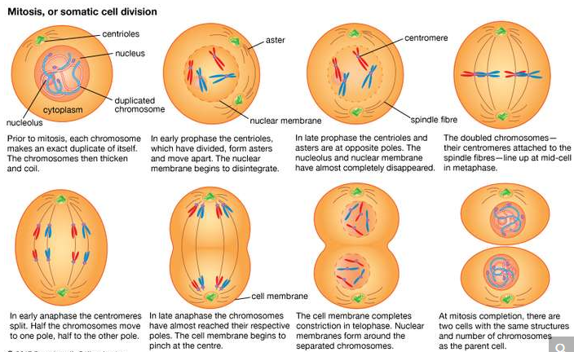

mitosis

One cell gives rise to two genetically identical daughter cells during the process of mitosis.

Most tissues of the body grow by increasing their cell number, but this growth is highly regulated to maintain a balance between different tissues. In adults most cell division is involved in tissue renewal rather than growth, many types of cells undergoing continuous replacement. Skin cells, for example, are constantly being sloughed off and replaced; in this case, the mature differentiated cells do not divide, but their population is renewed by division of immature stem cells. In certain other cells, such as those of the liver, mature cells remain capable of division to allow growth or regeneration after injury.

In contrast to these patterns, other types of cells either cannot divide or are prevented from dividing by certain molecules produced by nearby cells. As a result, in the adult organism, some tissues have a greatly reduced capacity to renew damaged or diseased cells. Examples of such tissues include heart muscle, nerve cells of the central nervous system, and lens cells in mammals. Maintenance and repair of these cells is limited to replacing intracellular components rather than replacing entire cells.

**Duplication of the genetic material**

Before a cell can divide, it must accurately and completely duplicate the genetic information encoded in its DNA in order for its progeny cells to function and survive. This is a complex problem because of the great length of DNA molecules. Each human chromosome consists of a long double spiral, or helix, each strand of which consists of more than 100 million nucleotides.

The duplication of DNA is called DNA replication, and it is initiated by complex enzymes called DNA polymerases. These progress along the molecule, reading the sequences of nucleotides that are linked together to make DNA chains. Each strand of the DNA double helix, therefore, acts as a template specifying the nucleotide structure of a new growing chain. After replication, each of the two daughter DNA double helices consists of one parental DNA strand wound around one newly synthesized DNA strand.

In order for DNA to replicate, the two strands must be unwound from each other. Enzymes called helicases unwind the two DNA strands, and additional proteins bind to the separated strands to stabilize them and prevent them from pairing again. In addition, a remarkable class of enzyme called DNA topoisomerase removes the helical twists by cutting either one or both strands and then resealing the cut. These enzymes can also untangle and unknot DNA when it is tightly coiled into a chromatin fibre.

In the circular DNA of prokaryotes, replication starts at a unique site called the origin of replication and then proceeds in both directions around the molecule until the two processes meet, producing two daughter molecules. In rapidly growing prokaryotes, a second round of replication can start before the first has finished. The situation in eukaryotes is more complicated, as replication moves more slowly than in prokaryotes. At 500 to 5,000 nucleotides per minute (versus 100,000 nucleotides per minute in prokaryotes), it would take a human chromosome about a month to replicate if started at a single site. Actually, replication begins at many sites on the long chromosomes of animals, plants, and fungi. Distances between adjacent initiation sites are not always the same; for example, they are closer in the rapidly dividing embryonic cells of frogs or flies than in adult cells of the same species.

Accurate DNA replication is crucial to ensure that daughter cells have exact copies of the genetic information for synthesizing proteins. Accuracy is achieved by a “proofreading” ability of the DNA polymerase itself. It can erase its own errors and then synthesize anew. There are also repair systems that correct genetic damage to DNA. For example, the incorporation of an incorrect nucleotide, or damage caused by mutagenic agents, can be corrected by cutting out a section of the daughter strand and recopying the parental strand.

**Cell division**

**Mitosis and cytokinesis**

In eukaryotes the processes of DNA replication and cell division occur at different times of the cell division cycle. During cell division, DNA condenses to form short, tightly coiled, rodlike chromosomes. Each chromosome then splits longitudinally, forming two identical chromatids. Each pair of chromatids is divided between the two daughter cells during mitosis, or division of the nucleus, a process in which the chromosomes are propelled by attachment to a bundle of microtubules called the mitotic spindle.

Mitosis can be divided into five phases. In prophase the mitotic spindle forms and the chromosomes condense. In prometaphase the nuclear envelope breaks down (in many but not all eukaryotes) and the chromosomes attach to the mitotic spindle. Both chromatids of each chromosome attach to the spindle at a specialized chromosomal region called the kinetochore. In metaphase the condensed chromosomes align in a plane across the equator of the mitotic spindle. Anaphase follows as the separated chromatids move abruptly toward opposite spindle poles. Finally, in telophase a new nuclear envelope forms around each set of unraveling chromatids.

An essential feature of mitosis is the attachment of the chromatids to opposite poles of the mitotic spindle. This ensures that each of the daughter cells will receive a complete set of chromosomes. The mitotic spindle is composed of microtubules, each of which is a tubular assembly of molecules of the protein tubulin. Some microtubules extend from one spindle pole to the other, while a second class extends from one spindle pole to a chromatid. Microtubules can grow or shrink by the addition or removal of tubulin molecules. The shortening of spindle microtubules at anaphase propels attached chromatids to the spindle poles, where they unravel to form new nuclei.

The two poles of the mitotic spindle are occupied by centrosomes, which organize the microtubule arrays. In animal cells each centrosome contains a pair of cylindrical centrioles, which are themselves composed of complex arrays of microtubules. Centrioles duplicate at a precise time in the cell division cycle, usually close to the start of DNA replication.

After mitosis comes cytokinesis, the division of the cytoplasm. This is another process in which animal and plant cells differ. In animal cells cytokinesis is achieved through the constriction of the cell by a ring of contractile microfilaments consisting of actin and myosin, the proteins involved in muscle contraction and other forms of cell movement. In plant cells the cytoplasm is divided by the formation of a new cell wall, called the cell plate, between the two daughter cells. The cell plate arises from small Golgi-derived vesicles that coalesce in a plane across the equator of the late telophase spindle to form a disk-shaped structure. In this process, each vesicle contributes its membrane to the forming cell membranes and its matrix contents to the forming cell wall. A second set of vesicles extends the edge of the cell plate until it reaches and fuses with the sides of the parent cell, thereby completely separating the two new daughter cells. At this point, cellulose synthesis commences, and the cell plate becomes a primary cell wall .

**Meiosis**

A specialized division of chromosomes called meiosis occurs during the formation of the reproductive cells, or gametes, of sexually reproducing organisms. Gametes such as ova, sperm, and pollen begin as germ cells, which, like other types of cells, have two copies of each gene in their nuclei. The chromosomes composed of these matching genes are called homologs. During DNA replication, each chromosome duplicates into two attached chromatids. The homologous chromosomes are then separated to opposite poles of the meiotic spindle by microtubules similar to those of the mitotic spindle. At this stage in the meiosis of germ cells, there is a crucial difference from the mitosis of other cells. In meiosis the two chromatids making up each chromosome remain together, so that whole chromosomes are separated from their homologous partners. Cell division then occurs, followed by a second division that resembles mitosis more closely in that it separates the two chromatids of each remaining chromosome. In this way, when meiosis is complete, each mature gamete receives only one copy of each gene instead of the two copies present in other cells.

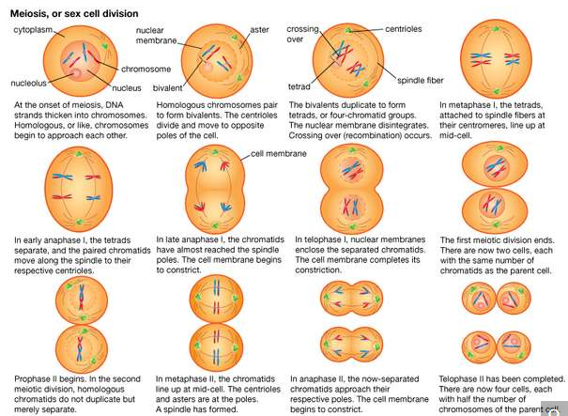

The formation of gametes (sex cells) occurs during the process of meiosis.

The cell division cycle

In prokaryotes, DNA synthesis can take place uninterrupted between cell divisions, and new cycles of DNA synthesis can begin before previous cycles have finished. In contrast, eukaryotes duplicate their DNA exactly once during a discrete period between cell divisions. This period is called the S (for synthetic) phase. It is preceded by a period called G1 (meaning “first gap”) and followed by a period called G2, during which nuclear DNA synthesis does not occur.

The four periods G1, S, G2, and M (for mitosis) make up the cell division cycle. The cell cycle characteristically lasts between 10 and 20 hours in rapidly proliferating adult cells, but it can be arrested for weeks or months in quiescent cells or for a lifetime in neurons of the brain. Prolonged arrest of this type usually occurs during the G1 phase and is sometimes referred to as G0. In contrast, some embryonic cells, such as those of fruit flies (vinegar flies), can complete entire cycles and divide in only 11 minutes. In these exceptional cases, G1 and G2 are undetectable, and mitosis alternates with DNA synthesis. In addition, the duration of the S phase varies dramatically. The fruit fly embryo takes only four minutes to replicate its DNA, compared with several hours in adult cells of the same species.

**Controlled proliferation**

Several studies have identified the transition from the G1 to the S phase as a crucial control point of the cell cycle. Stimuli are known to cause resting cells to proliferate by inducing them to leave G1 and begin DNA synthesis. These stimuli, called growth factors, are naturally occurring proteins specific to certain groups of cells in the body. They include nerve growth factor, epidermal growth factor, and platelet-derived growth factor. Such factors may have important roles in the healing of wounds as well as in the maintenance and growth of normal tissues. Many growth factors are known to act on the external membrane of the cell, by interacting with specialized protein receptor molecules. These respond by triggering further cellular changes, including an increase in calcium levels that makes the cell interior more alkaline and the addition of phosphate groups to the amino acid tyrosine in proteins. The complex response of cells to growth factors is of fundamental importance to the control of cell proliferation.

**Failure of proliferation control**

Cancer can arise when the controlling factors over cell growth fail and allow a cell and its descendants to keep dividing at the expense of the organism. Studies of viruses that transform cultured cells and thus lead to the loss of control of cell growth have provided insight into the mechanisms that drive the formation of tumours. Transformed cells may differ from their normal progenitors by continuing to proliferate at very high densities, in the absence of growth factors, or in the absence of a solid substrate for support.

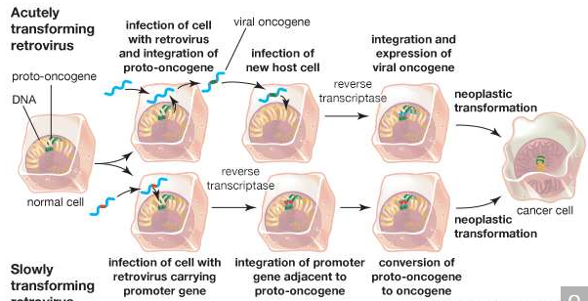

cancer-causing retroviruses

Retroviral insertion can convert a proto-oncogene, integral to the control of cell division, into an oncogene, the agent responsible for transforming a healthy cell into a cancer cell. An acutely transforming retrovirus (shown at top), which produces tumours within weeks of infection, incorporates genetic material from a host cell into its own genome upon infection, forming a viral oncogene. When the viral oncogene infects another cell, an enzyme called reverse transcriptase copies the single-stranded genetic material into double-stranded DNA, which is then integrated into the cellular genome. A slowly transforming retrovirus (shown at bottom), which requires months to elicit tumour growth, does not disrupt cellular function through the insertion of a viral oncogene. Rather, it carries a promoter gene that is integrated into the cellular genome of the host cell next to or within a proto-oncogene, allowing conversion of the proto-oncogene to an oncogene.

Major advances in the understanding of growth control have come from studies of the viral genes that cause transformation. These viral oncogenes have led to the identification of related cellular genes called protooncogenes. Protooncogenes can be altered by mutation or epigenetic modification, which converts them into oncogenes and leads to cell transformation. Specific oncogenes are activated in particular human cancers. For example, an oncogene called RAS is associated with many epithelial cancers, while another, called MYC, is associated with leukemias.

An interesting feature of oncogenes is that they may act at different levels corresponding to the multiple steps seen in the development of cancer. Some oncogenes immortalize cells so that they divide indefinitely, whereas normal cells die after a limited number of generations. Other oncogenes transform cells so that they grow in the absence of growth factors. A combination of these two functions leads to loss of proliferation control, whereas each of these functions on its own cannot. The mode of action of oncogenes also provides important clues to the nature of growth control and cancer. For example, some oncogenes are known to encode receptors for growth factors that may cause continuous proliferation in the absence of appropriate growth factors.

Loss of growth control has the added consequence that cells no longer repair their DNA effectively, and thus aberrant mitoses occur. As a result, additional mutations arise that subvert a cell’s normal constraints to remain in its tissue of origin. Epithelial tumour cells, for example, acquire the ability to cross the basal lamina and enter the bloodstream or lymphatic system, where they migrate to other parts of the body, a process called metastasis. When cells metastasize to distant tissues, the tumour is described as malignant, whereas prior to metastasis a tumour is described as benign.

**Cell Differentiation**

Adult organisms are composed of a number of distinct cell types. Cells are organized into tissues, each of which typically contains a small number of cell types and is devoted to a specific physiological function. For example, the epithelial tissue lining the small intestine contains columnar absorptive cells, mucus-secreting goblet cells, hormone-secreting endocrine cells, and enzyme-secreting Paneth cells. In addition, there exist undifferentiated dividing cells that lie in the crypts between the intestinal villi and serve to replace the other cell types when they become damaged or worn out. Another example of a differentiated tissue is the skeletal tissue of a long bone, which contains osteoblasts (large cells that synthesize bone) in the outer sheath and osteocytes (mature bone cells) and osteoclasts (multinucleate cells involved in bone remodeling) within the matrix.

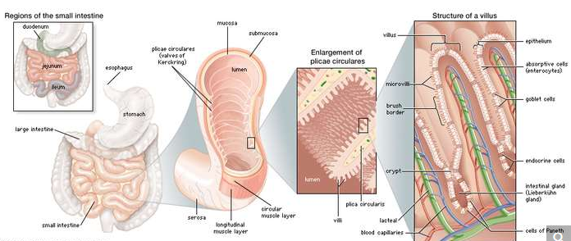

The small intestine contains many distinct types of cells, each of which serves a specific function.

In general, the simpler the overall organization of the animal, the fewer the number of distinct cell types that they possess. Mammals contain more than 200 different cell types, whereas simple invertebrate animals may have only a few different types. Plants are also made up of differentiated cells, but they are quite different from the cells of animals. For example, a leaf in a higher plant is covered with a cuticle layer of epidermal cells. Among these are pores composed of two specialized cells, which regulate gaseous exchange across the epidermis. Within the leaf is the mesophyll, a spongy tissue responsible for photosynthetic activity. There are also veins composed of xylem elements, which transport water up from the soil, and phloem elements, which transport products of photosynthesis to the storage organs.

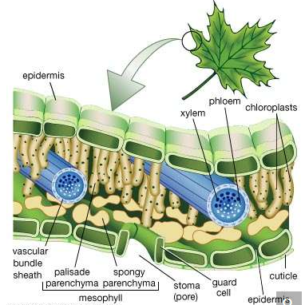

Structures of a leafThe epidermis is often covered with a waxy protective cuticle that helps prevent water loss from inside the leaf. Oxygen, carbon dioxide, and water enter and exit the leaf through pores (stomata) scattered mostly along the lower epidermis. The stomata are opened and closed by the contraction and expansion of surrounding guard cells. The vascular, or conducting, tissues are known as xylem and phloem; water and minerals travel up to the leaves from the roots through the xylem, and sugars made by photosynthesis are transported to other parts of the plant through the phloem. Photosynthesis occurs within the chloroplast-containing mesophyll layer.

The various cell types have traditionally been recognized and classified according to their appearance in the light microscope following the process of fixing, processing, sectioning, and staining tissues that is known as histology. Classical histology has been augmented by a variety of more discriminating techniques. Electron microscopy allows for higher magnifications. Histochemistry involves the use of coloured precipitating substrates to stain particular enzymes in situ. Immunohistochemistry uses specific antibodies to identify particular substances, usually proteins or carbohydrates, within cells. In situ hybridization involves the use of nucleic acid probes to visualize the location of specific messenger RNAs (mRNA). These modern methods have allowed the identification of more cell types than could be visualized by classical histology, particularly in the brain, the immune system, and among the hormone-secreting cells of the endocrine system.

**The differentiated state**

The biochemical basis of cell differentiation is the synthesis by the cell of a particular set of proteins, carbohydrates, and lipids. This synthesis is catalyzed by proteins called enzymes. Each enzyme in turn is synthesized in accordance with a particular gene, or sequence of nucleotides in the DNA of the cell nucleus. A particular state of differentiation, then, corresponds to the set of genes that is expressed and the level to which it is expressed.

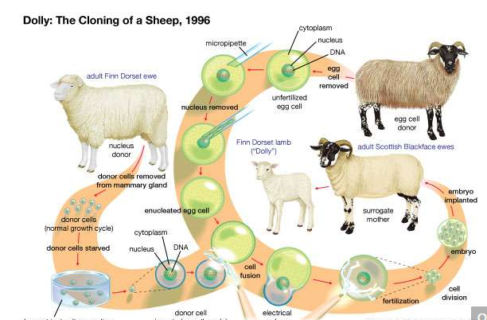

Dolly the sheep was successfully cloned in 1996 by fusing the nucleus from a mammary-gland cell of a Finn Dorset ewe into an enucleated egg cell taken from a Scottish Blackface ewe. Carried to term in the womb of another Scottish Blackface ewe, Dolly was a genetic copy of the Finn Dorset ewe.

It is believed that all of an organism’s genes are present in each cell nucleus, no matter what the cell type, and that differences between tissues are not due to the presence or absence of certain genes but are due to the expression of some and the repression of others. In animals the best evidence for retention of the entire set of genes comes from whole animal cloning experiments in which the nucleus of a differentiated cell is substituted for the nucleus of a fertilized egg. In many species this can result in the development of a normal embryo that contains the full range of body parts and cell types. Likewise, in plants it is often possible to grow complete embryos from individual cells in tissue culture. Such experiments show that any nucleus has the genetic information required for the growth of a developing organism, and they strongly suggest that, for most tissues, cell differentiation arises from the regulation of genetic activity rather than the removal or destruction of unwanted genes. The only known exception to this rule comes from the immune system, where segments of DNA in developing white blood cells are slightly rearranged, producing a wide variety of antibody and receptor molecules.

At the molecular level there are many ways in which the expression of a gene can be differentially regulated in different cell types. There may be differences in the copying, or transcription, of the gene into RNA; in the processing of the initial RNA transcript into mRNA; in the control of mRNA movement to the cytoplasm; in the translation of mRNA to protein; or in the stability of mRNA. However, the control of transcription has the most influence over gene expression and has received the most detailed analysis.

The DNA in the cell nucleus exists in the form of chromatin, which is made up of DNA bound to histones (simple alkaline proteins) and other nonhistone proteins. Most of the DNA is complexed into repeating structures called nucleosomes, each of which contains eight molecules of histone. Active genes are found in parts of the DNA where the chromatin has an “open” configuration, in which regulatory proteins are able to gain access to the DNA. The degree to which the chromatin opens depends on chemical modifications of the outer parts of the histone molecules and on the presence or absence of particular nonhistone proteins. Transcriptional control is exerted with the help of regulatory sequences that are found associated with a gene, such as the promoter sequence, a region near the start of the gene, and enhancer sequences, regions that lie elsewhere within the DNA that augment the activity of enzymes involved in the process of transcription. Whether or not transcription occurs depends on the binding of transcription factors to these regulatory sequences. Transcription factors are proteins that usually possess a DNA-binding region, which recognizes the specific regulatory sequence in the DNA, and an effector region, which activates or inhibits transcription. Transcription factors often work by recruiting enzymes that add modifications (e.g., acetyl groups or methyl groups) to or remove modifications from the outer parts of the histone molecules. This controls the folding of the chromatin and the accessibility of the DNA to RNA polymerase and other transcription factors.

In general, it requires several transcription factors working in combination to activate a gene. For example, the chicken delta 1 crystallin gene, normally expressed only in the lens of the eye, has a promoter that contains binding sites for two activating transcription factors and an enhancer that contains binding sites for two other activating transcription factors. There is also an additional enhancer site that can bind either an activator (deltaEF3) or a repressor (deltaEF1). Successful transcription requires that all these sites are occupied by the correct transcription factors.

Fully differentiated cells are qualitatively different from one another. States of terminal differentiation are stable and persistent, both in the lifetime of the cell and in successive cell generations (in the case of differentiated types that are capable of continued cell division). The inherent stability of the differentiated state is maintained by various processes, including feedback activation of genes by their own products and repression of inactive genes. Chromatin structure may be important in maintaining states of differentiation, although it is still unclear whether this can be maintained during DNA replication, which involves temporary removal of chromosomal proteins and unwinding of the DNA double helix.

A type of differentiation control that is maintained during DNA replication is the methylation of DNA, which tends to recruit histone deacetylases and hence close up the structure of the chromatin. DNA methylation occurs when a methyl group is attached to the exterior, or sugar-phosphate side, of a cytosine (C) residue. Cytosine methylation occurs only on a C nucleotide when it is connected to a G (guanine) nucleotide on the same strand of DNA. These nucleotide pairings are called CG dinucleotides. One class of DNA methylase enzyme can introduce new methylations when required, whereas another class, called maintenance methylases, methylates CG dinucleotides in the DNA double helix only when the CG of the complementary strand is already methylated. Each time the methylated DNA is replicated, the old strand has the methyl groups and the new strand does not. The maintenance methylase will then add methyl groups to all the CGs opposite the existing methyl groups to restore a fully methylated double helix. This mechanism guarantees stability of the DNA methylation pattern, and hence the differentiated state, during the processes of DNA replication and cell division.

**The process of differentiation**

Differentiation from visibly undifferentiated precursor cells occurs during embryonic development, during metamorphosis of larval forms, and following the separation of parts in asexual reproduction. It also takes place in adult organisms during the renewal of tissues and the regeneration of missing parts. Thus, cell differentiation is an essential and ongoing process at all stages of life.

The visible differentiation of cells is only the last of a progressive sequence of states. In each state, the cell becomes increasingly committed toward one type of cell into which it can develop. States of commitment are sometimes described as “specification” to represent a reversible type of commitment and as “determination” to represent an irreversible commitment. Although states of specification and determination both represent differential gene activity, the properties of embryonic cells are not necessarily the same as those of fully differentiated cells. In particular, cells in specification states are usually not stable over prolonged periods of time.

Two mechanisms bring about altered commitments in the different regions of the early embryo: cytoplasmic localization and induction. Cytoplasmic localization is evident in the earliest stages of development of the embryo. During this time, the embryo divides without growth, undergoing cleavage divisions that produce separate cells called blastomeres. Each blastomere inherits a certain region of the original egg cytoplasm, which may contain one or more regulatory substances called cytoplasmic determinants. When the embryo has become a solid mass of blastomeres (called a morula), it generally consists of two or more differently committed cell populations—a result of the blastomeres having incorporated different cytoplasmic determinants. Cytoplasmic determinants may consist of mRNA or protein in a particular state of activation. An example of the influence of a cytoplasmic determinant is a receptor called Toll, located in the membranes of Drosophila (fruit fly) eggs. Activation of Toll ensures that the blastomeres will develop into ventral (underside) structures, while blastomeres containing inactive Toll will produce cells that will develop into dorsal (back) structures.

In induction, the second mechanism of commitment, a substance secreted by one group of cells alters the development of another group. In early development, induction is usually instructive; that is, the tissue assumes a different state of commitment in the presence of the signal than it would in the absence of the signal. Inductive signals often take the form of concentration gradients of substances that evoke a number of different responses at different concentrations. This leads to the formation of a sequence of groups of cells, each in a different state of specification. For example, in Xenopus (clawed frog) the early embryo contains a signaling centre called the organizer that secretes inhibitors of bone morphogenetic proteins (BMPs), leading to a ventral-to-dorsal (belly-to-back) gradient of BMP activity. The activity of BMP in the ventral region of the embryo suppresses the expression of transcription factors involved in the formation of the central nervous system and segmented muscles. Suppression ensures that these structures are formed only on the dorsal side, where there is decreased activity of BMP.

The final stage of differentiation often involves the formation of several types of differentiated cells from one precursor or stem cell population. Terminal differentiation occurs not only in embryonic development but also in many tissues in postnatal life. Control of this process depends on a system of lateral inhibition in which cells that are differentiating along a particular pathway send out signals that repress similar differentiation by their neighbours. For example, in the developing central nervous system of vertebrates, neurons arise from a simple tube of neuroepithelium, the cells of which possess a surface receptor called Notch. These cells also possess another cell surface molecule called Delta that can bind to and activate Notch on adjacent cells. Activation of Notch initiates a cascade of intracellular events that results in suppression of Delta production and suppression of neuronal differentiation. This means that the neuroepithelium generates only a few cells with high expression of Delta surrounded by a larger number of cells with low expression of Delta. High Delta production and low Notch activation makes the cells develop into neurons. Low Delta production and high Notch activation makes the cells remain as precursor cells or become glial (supporting) cells. A similar mechanism is known to produce the endocrine cells of the pancreas and the goblet cells of the intestinal epithelium. Such lateral inhibition systems work because cells in a population are never quite identical to begin with. There are always small differences, such as in the number of Delta molecules displayed on the cell surface. The mechanism of lateral inhibition amplifies these small differences, using them to bring about differential gene expression that leads to stable and persistent states of cell differentiation.

**Errors in differentiation**

Three classes of abnormal cell differentiation are dysplasia, metaplasia, and anaplasia. Dysplasia indicates an abnormal arrangement of cells, usually arising from a disturbance in their normal growth behaviour. Some dysplasias are precursor lesions to cancer, whereas others are harmless and regress spontaneously. For example, dysplasia of the uterine cervix, called cervical intraepithelial neoplasia (CIN), may progress to cervical cancer. It can be detected by cervical smear cytology tests (Pap smears).

Metaplasia is the conversion of one cell type into another. In fact, it is not usually the differentiated cells themselves that change but rather the stem cell population from which they are derived. Metaplasia commonly occurs where chronic tissue damage is followed by extensive regeneration. For example, squamous metaplasia of the bronchi occurs when the ciliated respiratory epithelial cells of people who smoke develop into squamous, or flattened, cells. In intestinal metaplasia of the stomach, patches resembling intestinal tissue arise in the gastric mucosa, often in association with gastric ulcers. Both of these types of metaplasia may progress to cancer.

Anaplasia is a loss of visible differentiation that can occur in advanced cancer. In general, early cancers resemble their tissue of origin and are described and classified by their pattern of differentiation. However, as they develop, they produce variants of more abnormal appearance and increased malignancy. Finally, a highly anaplastic growth can occur, in which the cancerous cells bear no visible relation to the parent tissue.

**The Evolution Of Cells**

**The development of genetic information**

Life on Earth could not exist until a collection of catalysts appeared that could promote the synthesis of more catalysts of the same kind. Early stages in the evolutionary pathway of cells presumably centred on RNA molecules, which not only present specific catalytic surfaces but also contain the potential for their own duplication through the formation of a complementary RNA molecule. It is assumed that a small RNA molecule eventually appeared that was able to catalyze its own duplication.

Imperfections in primitive RNA replication likely gave rise to many variant autocatalytic RNA molecules. Molecules of RNA that acquired variations that increased the speed or the fidelity of self-replication would have outmultiplied other, less-competent RNA molecules. In addition, other small RNA molecules that existed in symbiosis with autocatalytic RNA molecules underwent natural selection for their ability to catalyze useful secondary reactions such as the production of better precursor molecules. In this way, sophisticated families of RNA catalysts could have evolved together, since cooperation between different molecules produced a system that was much more effective at self-replication than a collection of individual RNA catalysts.

Another major step in the evolution of the cell would have been the development, in one family of self-replicating RNA, of a primitive mechanism of protein synthesis. Protein molecules cannot provide the information for the synthesis of other protein molecules like themselves. This information must ultimately be derived from a nucleic acid sequence. Protein synthesis is much more complex than RNA synthesis, and it could not have arisen before a group of powerful RNA catalysts evolved. Each of these catalysts presumably has its counterpart among the RNA molecules that function in the current cell: (1) there was an information RNA molecule, much like messenger RNA (mRNA), whose nucleotide sequence was read to create an amino acid sequence; (2) there was a group of adaptor RNA molecules, much like transfer RNA (tRNA), that could bind to both mRNA and a specific activated amino acid; and (3) finally, there was an RNA catalyst, much like ribosomal RNA (rRNA), that facilitated the joining together of the amino acids aligned on the mRNA by the adaptor RNA.

At some point in the evolution of biological catalysts, the first cell was formed. This would have required the partitioning of the primitive biological catalysts into individual units, each surrounded by a membrane. Membrane formation might have occurred quite simply, since many amphiphilic molecules—half hydrophobic (water-repelling) and half hydrophilic (water-loving)—aggregate to form bilayer sheets in which the hydrophobic portions of the molecules line up in rows to form the interior of the sheet and leave the hydrophilic portions to face the water. Such bilayer sheets can spontaneously close up to form the walls of small, spherical vesicles, as can the phospholipid bilayer membranes of present-day cells.

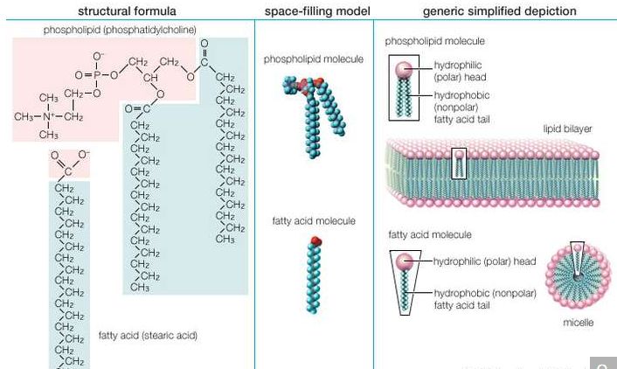

Structure and properties of two representative lipidsBoth stearic acid (a fatty acid) and phosphatidylcholine (a phospholipid) are composed of chemical groups that form polar “heads” and nonpolar “tails.” The polar heads are hydrophilic, or soluble in water, whereas the nonpolar tails are hydrophobic, or insoluble in water. Lipid molecules of this composition spontaneously form aggregate structures such as micelles and lipid bilayers, with their hydrophilic ends oriented toward the watery medium and their hydrophobic ends shielded from the water.

As soon as the biological catalysts became compartmentalized into small individual units, or cells, the units would have begun to compete with one another for the same resources. The active competition that ensued must have greatly accelerated evolutionary change, serving as a powerful force for the development of more efficient cells. In this way, cells eventually arose that contained new catalysts, enabling them to use simpler, more abundant precursor molecules for their growth. Because these cells were no longer dependent on preformed ingredients for their survival, they were able to spread far beyond the limited environments where the first primitive cells arose.

It is often assumed that the first cells appeared only after the development of a primitive form of protein synthesis. However, it is by no means certain that cells cannot exist without proteins, and it has been suggested that the first cells contained only RNA catalysts. In either case, protein molecules, with their chemically varied side chains, are more powerful catalysts than RNA molecules; therefore, as time passed, cells arose in which RNA served primarily as genetic material, being directly replicated in each generation and inherited by all progeny cells in order to specify proteins.

As cells became more complex, a need would have arisen for a stabler form of genetic information storage than that provided by RNA. DNA, related to RNA yet chemically stabler, probably appeared rather late in the evolutionary history of cells. Over a period of time, the genetic information in RNA sequences was transferred to DNA sequences, and the ability of RNA molecules to replicate directly was lost. It was only at this point that the central process of biology—the synthesis, one after the other, of DNA, RNA, and protein—appeared.

**The development of metabolism**

The first cells presumably resembled prokaryotic cells in lacking nuclei and functional internal compartments, or organelles. These early cells were also anaerobic (not requiring oxygen), deriving their energy from the fermentation of organic molecules that had previously accumulated on the Earth over long periods of time. Eventually, more sophisticated cells evolved that could carry out primitive forms of photosynthesis, in which light energy was harnessed by membrane-bound proteins to form organic molecules with energy-rich chemical bonds. A major turning point in the evolution of life was the development of photosynthesizing prokaryotes requiring only water as an electron donor and capable of producing molecular oxygen. The descendants of these prokaryotes, the blue-green algae (cyanobacteria), still exist as viable life-forms. Their ancestors prospered to such an extent that the atmosphere became rich in the oxygen they produced. The free availability of this oxygen in turn enabled other prokaryotes to evolve aerobic forms of metabolism that were much more efficient in the use of organic molecules as a source of food.

The switch to predominantly aerobic metabolism is thought to have occurred in bacteria approximately 2 billion years ago, about 1.5 billion years after the first cells had formed. Aerobic eukaryotic cells (cells containing nuclei and all the other organelles) probably appeared about 1.5 billion years ago, their lineage having branched off much earlier from that of the prokaryotes. Eukaryotic cells almost certainly became aerobic by engulfing aerobic prokaryotes, with which they lived in a symbiotic relationship. The mitochondria found in both animals and plants are the descendants of such prokaryotes. Later, in branches of the eukaryotic lineage leading to plants and algae, a blue-green algaelike organism was engulfed to perform photosynthesis. It is likely that over a long period of time these organisms became the chloroplasts.

The eukaryotic cell thus apparently arose as an amalgam of different cells, in the process becoming an efficient aerobic cell whose plasma membrane was freed from energy metabolism—one of the major functions of the cell membrane of prokaryotes. The eukaryotic cell membrane was therefore able to become specialized for cell-to-cell communication and cell signaling. It may be partly for this reason that eukaryotic cells were eventually more successful at forming complex multicellular organisms than their simpler prokaryotic relatives.